A Computer Science (083) Project Report On

GAME ZONE

CBSE (2017-2018)

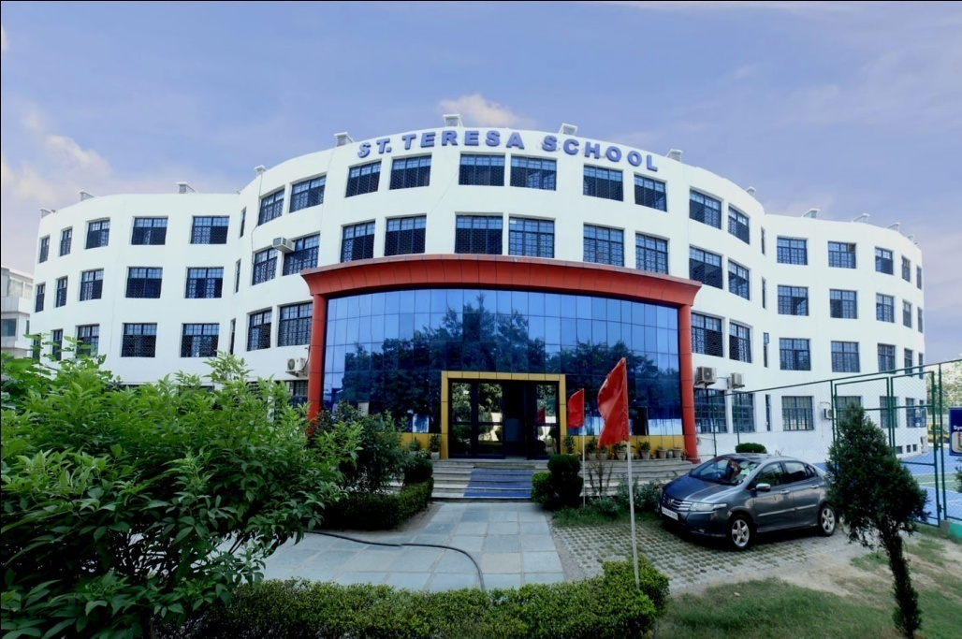

Submitted By

YATIN AGGARWAL

Class : XII A

Under the Guidance of

Ms. Vinita Sharma

PGT (Computer Science)

ST.TERESA SCHOOL

Shakti Khand 2, Indirapuram

Ghaziabad

**CERTIFICATE**

This is to certify that **YATIN AGGARWAL** of Class XII A has prepared the report on the Project entitled “Game Zone”. The report is the result of his efforts and endeavors. The report is found worthy of acceptance as final project for the subject Computer Science of Class XII. He has prepared the report under my guidance.

**(Ms. Vinita Sharma) (0830325)**

**PGT (Computer Science)**

**ST.TERESA SCHOOL**

**CERTIFICATE**

The project report entitled

“**GAME ZONE”,**

submitted by **YATIN AGGARWAL** of Class XII A for CBSE Senior Secondary Examination class XII of Computer Science has been examined.

**EXAMINER**

**Mr. RAJEEV KHOKHAR**

**(0650109)**

**PGT (Computer Science)**

**ACKNOWLEDGEMENT**

I would like to express a deep sense of thanks and gratitude to my project guide Ms. Vinita Sharma Ma’am for guiding me immensely through the course of the project. She always evinced keen interest in my work. His constructive advice and constant motivation have been responsible for successful completion of this project.

My since thanks goes to Ms. Renu Srivastava, Our principal ma’am, for her co-ordination in extending every possible support for the completion of this project.

I also thanks to my parents for their motivation and support.

Last but not the least, I would like to thank all those who had helped directly or indirectly towards the completion of this project.

**YATIN AGGARWAL**

**CLASS : XII A**

**CONTENTS**

1. HEADER FILES USED
2. CODING
3. OUTPUT SCREENS

**HEADER FILES USED**

1. **FSTREAM.H –** for file handling, cin, cout and endl
2. **STDLIB.H –** for rand(), exit() and srand() functions
3. **STRING.H –** for strcpy() function
4. **STDIO.H –** for gets(), remove() and rename() functions
5. **CONIO.H –** for textbackground(), textcolor(), clrscr() and getch() functions
6. **TIME.H –** for clock() function and CLOCKS_PER_SEC
7. **DOS.H –** for delay() function

**CODING**

#include<fstream.h>

#include<stdlib.h> //for rand(),exit() and srand() functions

#include<string.h> //for strcpy() function

#include<stdio.h> //for gets(), remove() and rename() functions

#include<conio.h> //for textbackground(), textcolor(), clrscr() and getch() functions

#include<time.h> //for clock() function and CLOCKS_PER_SEC

#include<dos.h> //for delay() function

//////////////////////////////////////////////////////////////////////////////

//*****************************function prototypes**************************//

//////////////////////////////////////////////////////////////////////////////

int srandomvalue();

long randomtimevalue();

void maindisplay();

void casino();

void quiz();

void calmaster();

void cricket();

void rock();

void animation();

//////////////////////////////////////////////////////////////////////////////

//*****************************function prototypes ends*********************//

//////////////////////////////////////////////////////////////////////////////

int a1=0,ca1=0,c1=0,r1=0,q1=0;

//////////////////////////////////////////////////////////////////////////////

//*****************************void main()**********************************//

//////////////////////////////////////////////////////////////////////////////

void main()

{

textbackground(RED);

textcolor(WHITE);

maindisplay();

}

//////////////////////////////////////////////////////////////////////////////

//*****************************void main() ends*****************************//

//////////////////////////////////////////////////////////////////////////////

//*****************************void srandomvalue()**************************//

int srandomvalue()

{

int srandom;

unsigned int sval;

sval=time(NULL);

srand(sval);

srandom=rand();

return srandom;

}

//*****************************void srandomvalue()**************************//

//*****************************void srandomtimevalue()**********************//

long randomtimevalue()

{

long random;

random=time(NULL);

return random;

}

//*****************************void srandomtimevalue()**********************//

//////////////////////////////////////////////////////////////////////////////

//*****************************void maindisplay()***************************//

//////////////////////////////////////////////////////////////////////////////

void maindisplay()

{

while(a1!=9)

{

ca1=0;

q1=0;

a1=0;

c1=0;

r1=0;

clrscr();

cout<<"\n\t\t\t\tGame Zone\n\n";

cout<<"1. Casino : A Number Guessing Game\n";

cout<<"2. Quiz\n";

cout<<"3. Calculation Master\n";

cout<<"4. Cricket\n";

cout<<"5. Rock Paper and Scissor\n";

cout<<"6. Exit\n";

cout<<"Your Choice : ";

a1=getch();

switch(a1)

{

case '1':

casino();

break;

case '2':

quiz();

break;

case '3':

calmaster();

break;

case '4':

cricket();

break;

case '5':

rock();

break;

case '6':

exit(0);

}

}

}

//////////////////////////////////////////////////////////////////////////////

//*****************************void maindisplay() ends**********************//

//////////////////////////////////////////////////////////////////////////////

//////////////////////////////////////////////////////////////////////////////

//*****************************void casino()********************************//

//////////////////////////////////////////////////////////////////////////////

void casino()

{

///////////////////////////////////////////////////////////////////////////

void casino1player();

void casino2player();

///////////////////////////////////////////////////////////////////////////

while(ca1!='3')

{

clrscr();

cout<<"\n\t\t\t\tGame Zone\n\n";

cout<<"\t\t\t\tCasino";

cout<<"\n1. 1-Player";

cout<<"\n2. 2-Player";

cout<<"\n3. Main Menu";

cout<<"\n4. Exit";

cout<<"\nYour Choice : ";

ca1=getch();

switch(ca1)

{

case '1':

casino1player();

break;

case '2':

casino2player();

break;

case '3':

break;

case '4':

exit(0);

}

}

}

//////////////////////////class casinoclass/////////////////////////////////

class casinoclass

{

int i;

long amount1,amount2,bet,betnum1,random0to9;

char continue1,betnum2;

public:

int won;

void casinoclass1()

{

i=0;

amount1=0;

amount2=0;

bet=0;

won=0;

continue1=NULL;

betnum2=NULL;

betnum1=0;

random0to9=0;

}

void casino1playerrules();

void casino1playerdeposit();

void casino1playermain();

~casinoclass()

{}

};

///////////////////////////class casinoclass ends///////////////////////////

///////////////////////void casino1playerrules()/////////////////////////////

void casinoclass :: casino1playerrules()

{

clrscr();

cout<<"\n\t\t\t\tGame Zone\n\n";

cout<<"\t\t\t\tCasino\n\t\t\t\t1 Player\n\t\t\t\tRules\n\n";

cout<<"-> This is a 1 Player Number Guessing game\n";

cout<<"-> Player deposits an initial amount to start the game\n";

cout<<"-> He/She Enters betting amount and guesses a number between 0 to 9\n";

cout<<"-> If he/she wins he/she will get 10 times of money he bets\n";

cout<<"-> If he/she bets on wrong number he will lost his betting amount.\n";

cout<<"-> The player (user or computer) who will have his amount 0 will lose the game\n";

cout<<"-> And the other Player will WIN the game";

cout<<"\n\nPress a enter to continue";

getch();

}

///////////////////////void casino1playerrules() ends///////////////////////

///////////////////////void casino1playerdeposit()///////////////////////////

void casinoclass :: casino1playerdeposit()

{

clrscr();

cout<<"\n\t\t\t\tGame Zone\n\n";

cout<<"\t\t\t\tCasino\n\t\t\t\t1 Player\n\n";

cout<<"Enter the amount to be deposited : ";

cin>>amount2;

cout<<endl<<amount2<<" is deposited by the user";

amount1=amount2;

cout<<"\nThe same amount is also deposited by the computer";

cout<<"\n\nUser Amount = "<<amount2;

cout<<"\nComputer Amount = "<<amount1;

cout<<"\n\nPress a enter to continue";

getch();

}

///////////////////////void casino1playerdeposit() ends/////////////////////

///////////////////////void casino1playermain()//////////////////////////////

void casinoclass :: casino1playermain()

{

while(((amount1!=0)&&(amount2!=0))&&continue1!='n')

{

random0to9=srandomvalue();

random0to9=random0to9%10;

clrscr();

cout<<"\n\t\t\t\tGame Zone\n\n";

cout<<"\t\t\t\tCasino\n\t\t\t\t1 Player\n\n";

if(i!=0)

{

cout<<"\nDo you want to change the Betting amount (y,any key) : ";

continue1=getch();

}

if((continue1=='y')||(i==0))

{

cout<<"\nYour Amount = "<<amount2;

cout<<"\nEnter the Betting amount : ";

cin>>bet;

}

if(amount1<bet)

{

bet=amount1;

cout<<"\nBet value changed to Computer Amount";

cout<<"\nBet Value = "<<bet;

}

else if(amount2<bet)

{

cout<<"\nBet not allowed (Less Money)";

getch();

continue;

}

cout<<"\nEnter the number on which you want to bet : ";

betnum2=getch();

if(betnum2=='0')

{

cout<<'0';

if(random0to9==0)

amount2+=bet*10;

else

amount2-=bet;

}

else if(betnum2=='1')

{

cout<<'1';

if(random0to9==1)

amount2+=bet*10;

else

amount2-=bet;

}

else if(betnum2=='2')

{

cout<<'2';

if(random0to9==2)

amount2+=bet*10;

else

amount2-=bet;

}

else if(betnum2=='3')

{

cout<<'3';

if(random0to9==3)

amount2+=bet*10;

else

amount2-=bet;

}

else if(betnum2=='4')

{

cout<<'4';

if(random0to9==4)

amount2+=bet*10;

else

amount2-=bet;

}

else if(betnum2=='5')

{

cout<<'5';

if(random0to9==5)

amount2+=bet*10;

else

amount2-=bet;

}

else if(betnum2=='6')

{

cout<<'6';

if(random0to9==6)

amount2+=bet*10;

else

amount2-=bet;

}

else if(betnum2=='7')

{

cout<<'7';

if(random0to9==7)

amount2+=bet*10;

else

amount2-=bet;

}

else if(betnum2=='8')

{

cout<<'8';

if(random0to9==8)

amount2+=bet*10;

else

amount2-=bet;

}

else

{

cout<<'9';

if(random0to9==9)

amount2+=bet*10;

else

amount2-=bet;

}

betnum1=randomtimevalue();

betnum1=betnum1%10;

for(int j=0;j<=9;j++)

{

if(betnum1==j)

{

if(random0to9==j)

amount1+=bet*10;

else

amount1-=bet;

}

}

cout<<"\n\nReal Value = "<<random0to9;

cout<<"\nBetting Amount = "<<bet;

cout<<"\nComputer Bet Value = "<<betnum1;

cout<<"\nComputer Amount = "<<amount1;

cout<<"\nYour Bet Value = "<<betnum2;

cout<<"\nYour Amount = "<<amount2;

if(amount1==0&&amount2==0)

{

cout<<"\n\nIts a Draw";

cout<<"\nPress Enter to continue";

getch();

break;

}

if(amount1==0)

{

cout<<"\n\nYou Won";

cout<<"\nPress Enter to continue";

getch();

break;

}

if(amount2==0)

{

cout<<"\n\nYou Lost";

cout<<"\nPress Enter to continue";

getch();

break;

}

cout<<"\n\nDo you want to continue (any key/n) : ";

continue1=getch();

i++;

}

}

///////////////////////void casino1playermain() ends////////////////////////

casinoclass cac1;

///////////////////////void casino1player()/////////////////////////////////

void casino1player()

{

cac1.casinoclass1();

cac1.casino1playerrules();

cac1.casino1playerdeposit();

cac1.casino1playermain();

}

///////////////////////void casino1player() ends////////////////////////////

//////////////////////////class casinoclass1////////////////////////////////

class casinoclass1

{

int i;

long amount1,amount2,bet,random0to9;

char continue1,continue2,betnum1,betnum2,player1[30],player2[30];

public:

int won;

void casinoclass2()

{

i=0;

amount1=0;

amount2=0;

bet=0;

won=0;

continue1=NULL;

continue2=NULL;

betnum1=NULL;

betnum2=NULL;

strcpy(player1,NULL);

strcpy(player2,NULL);

}

void casino2playerrules();

void casino2playergetnames();

void casino2playerdeposit();

void casino2playermain();

~casinoclass1()

{}

};

///////////////////////////class casinoclass1 ends//////////////////////////

///////////////////////void casino2playerrules()////////////////////////////

void casinoclass1 :: casino2playerrules()

{

clrscr();

cout<<"\n\t\t\t\tGame Zone\n\n";

cout<<"\t\t\t\tCasino\n\t\t\t\t2 Players\n\t\t\t\tRules\n\n";

cout<<"-> This is a 2 Player Number Guessing game\n";

cout<<"-> Players deposits an initial amount to start the game\n";

cout<<"-> Both the Players enters a betting amount and guesses a number between 0 to 9\n";

cout<<" respectively\n";

cout<<"-> The player who wins will get 10 times of money he/she bets\n";

cout<<"-> If the player bets on wrong number he will lose his betting amount.\n";

cout<<"-> The player who will have his amount 0 will lose the game\n";

cout<<"-> And the other Player will WIN the game";

cout<<"\n\nPress a enter to continue";

getch();

}

///////////////////////void casino2playerrules() ends///////////////////////

///////////////////////void casino2playergetnames()/////////////////////////

void casinoclass1 :: casino2playergetnames()

{

clrscr();

cout<<"\n\t\t\t\tGame Zone\n\n";

cout<<"\t\t\t\tCasino\n\t\t\t\t2 Players\n";

cout<<"Enter your names\n";

cout<<"Player 1 : ";

gets(player1);

cout<<"Player 2 : ";

gets(player2);

cout<<"\n\nPress enter to continue";

getch();

}

///////////////////////void casino2playergetnames() ends/////////////////////

///////////////////////void casino2playerdeposit()///////////////////////////

void casinoclass1 :: casino2playerdeposit()

{

clrscr();

cout<<"\n\t\t\t\tGame Zone\n\n";

cout<<"\t\t\t\tCasino\n\t\t\t\t2 Players\n\n";

cout<<"Enter the amount to be deposited : ";

cin>>amount1;

amount2=amount1;

cout<<"\n\n"<<player1<<"'s Amount = "<<amount1;

cout<<"\n"<<player2<<"'s Amount = "<<amount2;

cout<<"\n\nPress a enter to continue";

getch();

}

///////////////////////void casino2playerdeposit() ends/////////////////////

///////////////////////void casino2playermain()//////////////////////////////

void casinoclass1 :: casino2playermain()

{

while(((amount1!=0)&&(amount2!=0))&&continue1!='n')

{

random0to9=srandomvalue();

random0to9=random0to9%10;

clrscr();

cout<<"\n\t\t\t\tGame Zone\n\n";

cout<<"\t\t\t\tCasino\n\t\t\t\t2 Players\n\n";

cout<<"\n"<<player1<<"'s Amount = "<<amount1;

cout<<"\n"<<player2<<"'s Amount = "<<amount2;

if((i!=0)&&(i!=2))

{

cout<<"\nDo you want to change the Betting amount (y,any key) : ";

continue2=getch();

}

if((continue2=='y')||(i==0)||(i==2))

{

cout<<"\nEnter the Betting amount : ";

cin>>bet;

}

if((amount1<bet)||(amount2<bet))

{

cout<<"\nBet not allowed, Less Money";

if(amount1<bet)

cout<<" of "<<player1<<endl<<player1<<"'s Amount = "<<amount1;

else if(amount2<bet)

cout<<" of "<<player2<<endl<<player2<<"'s Amount = "<<amount2;

getch();

i=2;

continue;

}

cout<<endl<<player1<<"'s Turn\nEnter the number on which you want to bet : ";

betnum1=getch();

if(betnum2=='0')

{

cout<<'0';

if(random0to9==0)

amount1+=bet*10;

else

amount1-=bet;

}

else if(betnum1=='1')

{

cout<<'1';

if(random0to9==1)

amount1+=bet*10;

else

amount1-=bet;

}

else if(betnum1=='2')

{

cout<<'2';

if(random0to9==2)

amount1+=bet*10;

else

amount1-=bet;

}

else if(betnum1=='3')

{

cout<<'3';

if(random0to9==3)

amount1+=bet*10;

else

amount1-=bet;

}

else if(betnum1=='4')

{

cout<<'4';

if(random0to9==4)

amount1+=bet*10;

else

amount1-=bet;

}

else if(betnum1=='5')

{

cout<<'5';

if(random0to9==5)

amount1+=bet*10;

else

amount1-=bet;

}

else if(betnum1=='6')

{

cout<<'6';

if(random0to9==6)

amount1+=bet*10;

else

amount1-=bet;

}

else if(betnum1=='7')

{

cout<<'7';

if(random0to9==7)

amount1+=bet*10;

else

amount1-=bet;

}

else if(betnum1=='8')

{

cout<<'8';

if(random0to9==8)

amount1+=bet*10;

else

amount1-=bet;

}

else

{

cout<<'9';

if(random0to9==9)

amount1+=bet*10;

else

amount1-=bet;

}

cout<<endl<<player2<<"'s Turn\nEnter the number on which you want to bet : ";

betnum2=getch();

if(betnum2=='0')

{

cout<<'0';

if(random0to9==0)

amount2+=bet*10;

else

amount2-=bet;

}

else if(betnum2=='1')

{

cout<<'1';

if(random0to9==1)

amount2+=bet*10;

else

amount2-=bet;

}

else if(betnum2=='2')

{

cout<<'2';

if(random0to9==2)

amount2+=bet*10;

else

amount2-=bet;

}

else if(betnum2=='3')

{

cout<<'3';

if(random0to9==3)

amount2+=bet*10;

else

amount2-=bet;

}

else if(betnum2=='4')

{

cout<<'4';

if(random0to9==4)

amount2+=bet*10;

else

amount2-=bet;

}

else if(betnum2=='5')

{

cout<<'5';

if(random0to9==5)

amount2+=bet*10;

else

amount2-=bet;

}

else if(betnum2=='6')

{

cout<<'6';

if(random0to9==6)

amount2+=bet*10;

else

amount2-=bet;

}

else if(betnum2=='7')

{

cout<<'7';

if(random0to9==7)

amount2+=bet*10;

else

amount2-=bet;

}

else if(betnum2=='8')

{

cout<<'8';

if(random0to9==8)

amount2+=bet*10;

else

amount2-=bet;

}

else

{

cout<<'9';

if(random0to9==9)

amount2+=bet*10;

else

amount2-=bet;

}

cout<<"\n\nReal Value = "<<random0to9;

cout<<"\nBetting Amount = "<<bet;

cout<<"\n"<<player1<<"'s Bet Value = "<<betnum1;

cout<<"\n"<<player1<<"'s Amount = "<<amount1;

cout<<"\n"<<player2<<"'s Bet Value = "<<betnum2;

cout<<"\n"<<player2<<"'s Amount = "<<amount2;

if(amount1==0&&amount2==0)

{

cout<<"\n\nIts a Draw";

cout<<"\nPress Enter to continue";

getch();

break;

}

if(amount1==0)

{

cout<<"\n\n"<<player2<<" Won";

cout<<"\nPress Enter to continue";

getch();

break;

}

if(amount2==0)

{

cout<<"\n\n"<<player1<<" Won";

cout<<"\nPress Enter to continue";

getch();

break;

}

cout<<"\n\nDo you want to continue (any key/n) : ";

continue1=getch();

i=1;

}

}

///////////////////////void casino2playermain() ends////////////////////////

casinoclass1 cac2;

///////////////////////void casino2player()/////////////////////////////////

void casino2player()

{

cac2.casinoclass2();

cac2.casino2playerrules();

cac2.casino2playergetnames();

cac2.casino2playerdeposit();

cac2.casino2playermain();

}

///////////////////////void casino1player() ends////////////////////////////

//////////////////////////////////////////////////////////////////////////////

//*****************************void casino() ends***************************//

//////////////////////////////////////////////////////////////////////////////

//////////////////////////////////////////////////////////////////////////////

//*****************************void quiz()**********************************//

//////////////////////////////////////////////////////////////////////////////

void quiz()

{

///////////////////////////////////////////////////////////////////////////

void quiz1player();

void quiz2player();

///////////////////////////////////////////////////////////////////////////

while(q1!='3')

{

clrscr();

cout<<"\n\t\t\t\tGame Zone\n\n";

cout<<"\t\t\t\tQuiz";

cout<<"\n1. 1-Player";

cout<<"\n2. 2-Player";

cout<<"\n3. Main Menu";

cout<<"\n4. Exit";

cout<<"\nYour Choice : ";

q1=getch();

switch(q1)

{

case '1':

quiz1player();

break;

case '2':

quiz2player();

break;

case '3':

break;

case '4':

exit(0);

}

}

}

//////////////////////////class quizclass////////////////////////////////////

class quizclass

{

int an[5],i,ans;

float extratime;

char start,games,q[5][200];

public:

int won;

void quizclass1();

void quizrules();

void quizmain();

~quizclass()

{}

};

///////////////////////////class quizclass ends//////////////////////////

///////////////////////void quizclass1()/////////////////////////////////////

void quizclass :: quizclass1()

{

i=0;

won=0;

extratime=0;

start=NULL;

games=NULL;

for(int i=0;i<3;i++)

{

an[i]=0;

strcpy(q[i],NULL);

}

}

///////////////////////void quizclass1() ends///////////////////////////////

////////////////////////void quizrules()////////////////////////////////////

void quizclass :: quizrules()

{

clrscr();

cout<<"\n\t\t\t C++ PROGRAM QUIZ GAME\n";

cout<<"\n\n ________________________________________________________________________ ";

cout<<"\t\t\t WELCOME TO THE GAME\n";

cout<<"\n ________________________________________________________________________ ";

cout<<" ________________________________________________________________________ \n";

cout<<"\nPress any key to continue";

getch();

}

////////////////////////void quizrules() ends///////////////////////////////

///////////////////////void quizmain()/////////////////////////////////////

void quizclass :: quizmain()

{

////////////////////////////QUESTIONS/////////////////////////////////////////

////////////////////////QUESTION 1//////////////////////////////////////////

i=srandomvalue()%3;

if(i==0)

{

strcpy(q[0]," QUESTION 1 : Which Planet is not named after god?\n 1. Mercury\t\t\t2. Saturn\n 3. Earth\t\t\t4. None of these\n Your Choice : ");

an[0]=3;

}

else if(i==1)

{

strcpy(q[0]," Question 1 : Which part of human body reamains constant in size till death?\n 1. Eye Lens\t\t\t2. Nose\n 3. Tongue\t\t\t4. Heart\n Your Choice : ");

an[0]=1;

}

else

{

strcpy(q[0]," QUESTION 1 : How many times does a broken clock is right every day?\n 1. Four\t\t\t2. One\n 3. Two\t\t\t\t4. None of these\n Your Choice : ");

an[0]=3;

}

//////////////////QUESTION 2//////////////////////////////////////////////////////////

i=srandomvalue()%3;

if(i==0)

{

strcpy(q[1]," QUESTION 2 : Babies are born with?\n 1. Red Eyes\t\t\t\t2. Black Eyes\n 3. Blue Eyes\t\t\t\t4. None of these\n Your Choice : ");

an[1]=3;

}

else if(i==1)

{

strcpy(q[1]," Question 2 : Which animal can live for several weeks with its head cut off?\n 1. Chicken\t\t\t2. Rat\n 3. Cockroach\t\t\t4. Snake\n Your Choice : ");

an[1]=3;

}

else

{

strcpy(q[1]," QUESTION 2 : Which of the following sleeps with one eye open?\n 1. Cat\t\t\t\t\t2. Snake\n 3. Lion\t\t\t\t4. Dolphin\n Your Choice : ");

an[1]=4;

}

//////////////QUESTION 3//////////////////////////////////////////////////////////////

i=srandomvalue()%3;

if(i==0)

{

strcpy(q[2]," QUESTION 3 : Every time you sneeze some of your brain cells?\n 1. Increase in Size\t\t\t2. Decrease in Size\n 3. Die\t\t\t\t\t4. None of these\n Your Choice : ");

an[2]=3;

}

else if(i==1)

{

strcpy(q[2]," Question 3 : Which of the following never spoils?\n 1. Honey\t\t\t2. Potato\n 3. Milk\t\t\t4. None of these\n Your Choice : ");

an[2]=1;

}

else

{

strcpy(q[2]," QUESTION 3 : When you sneeze your heart stops for a?\n 1. Second\t\t\t\t2. Millisecond\n 3. Microsecond\t\t\t\t4. None of these\n Your Choice : ");

an[2]=2;

}

clock_t t;

for(i=0;i<3;i++)

{

extratime=0;

won=1;

clrscr();

cout<<"\n\t\t\t C++ PROGRAM QUIZ GAME\n"<<q[i];

extratime=clock();

ans=getch();

if((ans=='1'&&an[i]!=1)||(ans=='2'&&an[i]!=2)||(ans=='3'&&an[i]!=3)||(ans=='4'&&an[i]!=4))

won=2;

extratime=clock()-extratime;

extratime=float(extratime)/CLOCKS_PER_SEC;

if(won==1)

cout<<"Right Answer";

else

cout<<"Wrong Answer";

cout<<"\nTime : "<<extratime;

getch();

}

}

////////////////////////////////////////////////////////////////////////////

quizclass qc1;

///////////////////////void quiz1player()///////////////////////////////////

void quiz1player()

{

qc1.quizclass1();

qc1.quizrules();

qc1.quizmain();

}

///////////////////////void quiz1player() ends//////////////////////////////

//////////////////////////class quizclass1////////////////////////////////////

class quizclass1

{

int an1[5],an2[5],i,ans1,ans2;

float extratime1,extratime2;

char start,games,q1[3][200],q2[3][200];

public:

int won1,won2;

void quiz2playerclass1();

void quiz2playerrules();

void quiz2playermain();

~quizclass1()

{}

};

///////////////////////////class quizclass1 ends//////////////////////////

///////////////////////void quizclass1()/////////////////////////////////////

void quizclass1 :: quiz2playerclass1()

{

i=0;

won1=0;

won2=0;

extratime1=0;

extratime2=0;

start=NULL;

games=NULL;

for(int i=0;i<3;i++)

{

an1[i]=0;

an2[i]=0;

strcpy(q1[i],NULL);

strcpy(q2[i],NULL);

}

}

///////////////////////void quizclass1() ends///////////////////////////////

////////////////////////void quiz1playerrules()////////////////////////////////////

void quizclass1 :: quiz2playerrules()

{

clrscr();

cout<<"\n\t\t\t C++ PROGRAM QUIZ GAME\n";

cout<<"\n\n ________________________________________________________________________ ";

cout<<"\t\t\t WELCOME TO THE GAME\n";

cout<<"\n ________________________________________________________________________ ";

cout<<" ________________________________________________________________________ \n";

cout<<"\nPress any key to continue";

getch();

}

////////////////////////void quiz1playerrules() ends////////////////////////

///////////////////////void quiz1playermain()//////////////////////////////

void quizclass1 :: quiz2playermain()

{

////////////////////////////QUESTIONS/////////////////////////////////////////

////////////////////////QUESTION 1//////////////////////////////////////////

i=srandomvalue()%3;

if(i==0)

{

strcpy(q1[0]," QUESTION 1 : Which Planet is not named after god?\n 1. Mercury\t\t\t2. Saturn\n 3. Earth\t\t\t4. None of these\n Your Choice : ");

an1[0]=3;

strcpy(q2[0]," QUESTION 1 : Which part of human body reamains constant in size till death?\n 1. Eye Lens\t\t\t2. Nose\n 3. Tongue\t\t\t4. Heart\n Your Choice : ");

an2[0]=1;

}

else if(i==1)

{

strcpy(q1[0]," QUESTION 1 : Which part of human body reamains constant in size till death?\n 1. Eye Lens\t\t\t2. Nose\n 3. Tongue\t\t\t4. Heart\n Your Choice : ");

an1[0]=1;

strcpy(q2[0]," QUESTION 1 : Which Planet is not named after god?\n 1. Mercury\t\t\t2. Saturn\n 3. Earth\t\t\t4. None of these\n Your Choice : ");

an2[0]=3;

}

else

{

strcpy(q1[0]," QUESTION 1 : How many times does a broken clock is right every day?\n 1. Four\t\t\t2. One\n 3. Two\t\t\t\t4. None of these\n Your Choice : ");

an1[0]=3;

strcpy(q2[0]," QUESTION 1 : Which part of human body reamains constant in size till death?\n 1. Eye Lens\t\t\t2. Nose\n 3. Tongue\t\t\t4. Heart\n Your Choice : ");

an2[0]=1;

}

//////////////////QUESTION 2//////////////////////////////////////////////////////////

i=srandomvalue()%3;

if(i==0)

{

strcpy(q1[1]," QUESTION 2 : Babies are born with?\n 1. Red Eyes\t\t\t\t2. Black Eyes\n 3. Blue Eyes\t\t\t\t4. None of these\n Your Choice : ");

an1[1]=3;

strcpy(q2[1]," QUESTION 2 : Which animal can live for several weeks with its head cut off?\n 1. Chicken\t\t\t2. Rat\n 3. Cockroach\t\t\t4. Snake\n Your Choice : ");

an2[1]=3;

}

else if(i==1)

{

strcpy(q1[1]," QUESTION 2 : Which animal can live for several weeks with its head cut off?\n 1. Chicken\t\t\t2. Rat\n 3. Cockroach\t\t\t4. Snake\n Your Choice : ");

an1[1]=3;

strcpy(q2[1]," QUESTION 2 : Which of the following sleeps with one eye open?\n 1. Cat\t\t\t\t\t2. Snake\n 3. Lion\t\t\t\t4. Dolphin\n Your Choice : ");

an2[1]=4;

}

else

{

strcpy(q1[1]," QUESTION 2 : Which of the following sleeps with one eye open?\n 1. Cat\t\t\t\t\t2. Snake\n 3. Lion\t\t\t\t4. Dolphin\n Your Choice : ");

an1[1]=4;

strcpy(q2[1]," QUESTION 2 : Which animal can live for several weeks with its head cut off?\n 1. Chicken\t\t\t2. Rat\n 3. Cockroach\t\t\t4. Snake\n Your Choice : ");

an2[1]=3;

}

//////////////QUESTION 3//////////////////////////////////////////////////////////////

i=srandomvalue()%3;

if(i==0)

{

strcpy(q1[2]," QUESTION 3 : Every time you sneeze some of your brain cells?\n 1. Increase in Size\t\t\t2. Decrease in Size\n 3. Die\t\t\t\t\t4. None of these\n Your Choice : ");

an1[2]=3;

strcpy(q2[2]," QUESTION 3 : Which of the following never spoils?\n 1. Honey\t\t\t2. Potato\n 3. Milk\t\t\t4. None of these\n Your Choice : ");

an2[2]=1;

}

else if(i==1)

{

strcpy(q1[2]," QUESTION 3 : Which of the following never spoils?\n 1. Honey\t\t\t2. Potato\n 3. Milk\t\t\t4. None of these\n Your Choice : ");

an1[2]=1;

strcpy(q2[2]," QUESTION 3 : Every time you sneeze some of your brain cells?\n 1. Increase in Size\t\t\t2. Decrease in Size\n 3. Die\t\t\t\t\t4. None of these\n Your Choice : ");

an2[2]=3;

}

else

{

strcpy(q1[2]," QUESTION 3 : Every time you sneeze some of your brain cells?\n 1. Increase in Size\t\t\t2. Decrease in Size\n 3. Die\t\t\t\t\t4. None of these\n Your Choice : ");

an1[2]=3;

strcpy(q2[2]," QUESTION 3 : When you sneeze your heart stops for a?\n 1. Second\t\t\t\t2. Millisecond\n 3. Microsecond\t\t\t\t4. None of these\n Your Choice : ");

an2[2]=2;

}

clock_t t;

for(i=0;i<3;i++)

{

extratime1=0;

extratime2=0;

won1=0;

won2=0;

clrscr();

cout<<"\n\t\t\t C++ PROGRAM QUIZ GAME\n\n First Player\n"<<q1[i];

extratime1=clock();

ans1=getch();

extratime1=clock()-extratime1;

extratime1=float(extratime1)/CLOCKS_PER_SEC;

if((ans1=='1'&&an1[i]!=1)||(ans1=='2'&&an1[i]!=2)||(ans1=='3'&&an1[i]!=3)||(ans1=='4'&&an1[i]!=4))

won1=1;

clrscr();

cout<<"\n\t\t\t C++ PROGRAM QUIZ GAME\n\n Second Player\n"<<q2[i];

extratime2=clock();

ans2=getch();

extratime2=clock()-extratime2;

extratime2=float(extratime2)/CLOCKS_PER_SEC;

if((ans2=='1'&&an2[i]!=1)||(ans2=='2'&&an2[i]!=2)||(ans2=='3'&&an2[i]!=3)||(ans2=='4'&&an2[i]!=4))

won2=1;

clrscr();

cout<<"\n\t\t\t C++ PROGRAM QUIZ GAME\n\t\t\t\tScoreboard";

if(won1==1)

cout<<"\n Player 1 gave the Wrong Answer";

else

cout<<"\n Player 1 gave the Right Answer";

if(won2==1)

cout<<"\n Player 2 gave the Wrong Answer";

else

cout<<"\n Player 2 gave the Right Answer";

cout<<"\n\n Player 1 time : "<<extratime1<<"\n Player 2 time : "<<extratime2<<endl;

if((won1==0)&&(won2==0))

{

if(extratime1<extratime2)

cout<<" Player 1 won";

else if(extratime2<extratime1)

cout<<" Player 2 won";

}

else if(won1==0)

cout<<" Player 1 won";

else if(won2==0)

cout<<" Player 2 won";

else

cout<<" Draw";

getch();

}

}

////////////////////////////////////////////////////////////////////////////

quizclass1 qc2;

///////////////////////void quiz1player()///////////////////////////////////

void quiz2player()

{

qc2.quiz2playerclass1();

qc2.quiz2playerrules();

qc2.quiz2playermain();

}

///////////////////////void casino1player() ends////////////////////////////

//////////////////////////////////////////////////////////////////////////////

//*****************************void quiz() ends*****************************//

//////////////////////////////////////////////////////////////////////////////

//////////////////////////////////////////////////////////////////////////////

//*****************************void calmaster()*****************************//

//////////////////////////////////////////////////////////////////////////////

//////////////////////////class calclassname////////////////////////////////

class calclassname

{

public:

float timetaken;

char name[30];

calclassname()

{

timetaken=0;

strcpy(name,NULL);

}

void calmastergetname();

~calclassname()

{}

};

//////////////////////////class calclassname ends///////////////////////

//////////////////////////class calclass////////////////////////////////////

class calclass : public calclassname

{

long truevalue;

int truesum,usersum;

public:

int won;

void calclass1()

{

truevalue=0;

truesum=0;

usersum=0;

won=0;

}

void calmasterrules();

void calmastermain();

void calmasterputscore();

void calmasterscore();

float calmastergettimetaken()

{

return timetaken;

}

~calclass()

{}

};

///////////////////////////class cricketclass ends//////////////////////////

///////////////////////void calmasterrules()/////////////////////////////////

void calclass :: calmasterrules()

{

clrscr();

cout<<"\n\t\t\t\tGame Zone\n\n";

cout<<"\t\t\t\tCalculation Master\n\n";

cout<<"\n\nPress a enter to continue";

getch();

}

///////////////////////void calmasterrules() ends////////////////////////////

///////////////////////void calmastermain()/////////////////////////////////

void calclass :: calmastermain()

{

clrscr();

clock_t t;

cout<<"\n\t\t\t\tGame Zone\n\n";

cout<<"Calculation Master\n\n";

cout<<"Add the following numbers\n";

cout<<"Press Enter to start\n";

getch();

clrscr();

cout<<"\n\t\t\t\tGame Zone\n\n";

cout<<"Calculation Master\n\n";

t=clock();

for(int i=1;i<11;i++)

{

truevalue=(srandomvalue()%i)+1;

gotoxy(10,3+i+i);

cout<<truevalue<<endl;

truesum+=truevalue;

srandomvalue();

}

cout<<"Enter the Sum : ";

cin>>usersum;

clrscr();

cout<<"\n\t\t\t\tGame Zone\n\n";

cout<<"Calculation Master\n\n";

t=clock()-t;

timetaken=float(t)/CLOCKS_PER_SEC;

if(usersum==truesum)

{

cout<<"Well Done...";

won=1;

}

else

{

cout<<"Oops.....";

won=0;

}

cout<<"\nTime taken : "<<timetaken<<" seconds";

getch();

}

///////////////////////void calmastermain() ends////////////////////////////

///////////////////////void calmastergetname()////////////////////////////

void calclassname :: calmastergetname()

{

clrscr();

cout<<"\n\t\t\t\tGame Zone\n\n";

cout<<"\t\t\t\tCalculation Master\n\n";

cout<<"Enter your name : ";

gets(name);

getch();

}

///////////////////////void calmastergetname() ends///////////////////////

calclassname cacn1;

///////////////////////void calmasterputscore()///////////////////////////

void calclass :: calmasterputscore()

{

int i=0,n;

float timetaken[11];

char name[11][30];

fstream f;

f.open("yca1p.dat",ios::binary|ios::in);

timetaken[i]=cacn1.timetaken;

strcpy(name[i],cacn1.name);

i++;

while(f.read((char *)&cacn1,sizeof(cacn1)))

{

timetaken[i]=cacn1.timetaken;

strcpy(name[i],cacn1.name);

i++;

}

n=i;

if(n>11)

n=11;

f.close();

remove("yca1p.dat");

int j=0,h=0;

float temp;

char temp1[30];

f.open("yca1pe.dat",ios::binary|ios::out);

for(i=0;i<n;i++)

{

if(i>9)

continue;

h=0;

for(j=i+1;j<n;j++)

{

if((timetaken[i]>=timetaken[j])&&(i!=n-1))

{

temp=timetaken[j];

timetaken[j]=timetaken[i];

cacn1.timetaken=temp;

timetaken[i]=temp;

strcpy(temp1,name[j]);

strcpy(name[j],name[i]);

strcpy(cacn1.name,temp1);

strcpy(name[i],temp1);

h=1;

}

}

if(h==0)

{

cacn1.timetaken=timetaken[i];

strcpy(cacn1.name,name[i]);

}

f.write((char *)&cacn1,sizeof(cacn1));

}

f.close();

}

///////////////////////void calmasterscore()///////////////////////////////

void calclass :: calmasterscore()

{

fstream f;

int i;

if(won==1)

f.open("yca1pe.dat",ios::binary|ios::in);

else

f.open("yca1p.dat",ios::binary|ios::in);

clrscr();

cout<<"\n\t\t\t\tGame Zone\n";

cout<<"\t\t\t\tCalculation Master\n";

cout<<"\n\t\t\tScoreboard : ";

gotoxy(1,6);

cout<<"Rank";

gotoxy(10,6);

cout<<"Name";

gotoxy(60,6);

cout<<"Timetaken\n";

i=0;

while((f.read((char *)&cacn1,sizeof(cacn1)))&&(i<10))

{

gotoxy(1,i+7);

cout<<i+1;

gotoxy(10,i+7);

cout<<cacn1.name;

gotoxy(60,i+7);

cout<<cacn1.timetaken<<endl;

i++;

}

getch();

f.close();

rename("yca1pe.dat","yca1p.dat");

}

///////////////////////void calmasterscore()/////////////////////////////

calclass cal1;

////////////////////////////////////////////////////////////////////////////

void calmaster()

{

cal1.calclass1();

cal1.calmasterrules();

cal1.calmastermain();

if(cal1.won==1)

{

cacn1.calmastergetname();

cacn1.timetaken=cal1.calmastergettimetaken();

cal1.calmasterputscore();

}

cal1.calmasterscore();

}

//////////////////////////////////////////////////////////////////////////////

//*****************************void camlmaster() ends***********************//

//////////////////////////////////////////////////////////////////////////////

//////////////////////////////////////////////////////////////////////////////

//*****************************void cricket()*******************************//

//////////////////////////////////////////////////////////////////////////////

void cricket()

{

///////////////////////////////////////////////////////////////////////////

void cricket1player();

void cricket2player();

///////////////////////////////////////////////////////////////////////////

while(c1!='3')

{

clrscr();

cout<<"\n\t\t\t\tGame Zone\n\n";

cout<<"\t\t\t\tCricket";

cout<<"\n1. 1-Player";

cout<<"\n2. 2-Player";

cout<<"\n3. Main Menu";

cout<<"\n4. Exit";

cout<<"\nYour Choice : ";

c1=getch();

switch(c1)

{

case '1':

cricket1player();

break;

case '2':

cricket2player();

break;

case '3':

break;

case '4':

exit(0);

}

}

}

//////////////////////////class cricketclassname////////////////////////////

class cricketclassname

{

public:

float runrate;

char name[30];

cricketclassname()

{

runrate=0;

strcpy(name,NULL);

}

void cricket1playergetname();

~cricketclassname()

{}

};

//////////////////////////class cricketclassname ends///////////////////////

//////////////////////////class cricketclass////////////////////////////////

class cricketclass : public cricketclassname

{

int totalovers,random1to6,totalruns,over,ball,randomvalue,level,target,overrun;

float reqrunrate;

char continue1,run;

public:

int won;

void cricketclass1()

{

random1to6=0;

run='0';

overrun=0;

totalruns=0;

over=0;

randomvalue=0;

ball=0;

won=0;

continue1=NULL;

}

void cricket1playerrules();

void cricket1playerlevel();

void cricket1playerovers();

void cricket1playertargetscore();

void cricket1playerscoreboard();

void cricket1playermain();

void cricket1playerputscore();

void cricket1playerscores();

float cricket1playergetrunrate()

{

return runrate;

}

~cricketclass()

{}

};

///////////////////////////class cricketclass ends//////////////////////////

///////////////////////void cricket1playerrules()////////////////////////////

void cricketclass :: cricket1playerrules()

{

clrscr();

cout<<"\n\t\t\t\tGame Zone\n\n";

cout<<"\t\t\t\tCricket\n\t\t\t\t1 Player\n\t\t\t\tRules\n\n";

cout<<"-> This is a 1 Player Cricket game in which the player will guess any number\n";

cout<<" from 1 to 6 which would be considered as his run.\n";

cout<<"\n-> A number is generated at random by the computer\n";

cout<<"\n-> If the number generated by the computer is same as the number guessed by the\n";

cout<<" user then the user is OUT, else his number is considered as runs and would be";

cout<<" added in the total score.\n";

cout<<" You will also have to decide the number of overs (min-5,max-20) of the match\n";

cout<<"\n-> There are three levels in this game - Easy, Intermeditae and Expert\n";

cout<<" You will be given the Target according to the level chosen\n";

cout<<"\n-> If you are able to achieve the TARGET score in the specified overs\n";

cout<<" You will WIN the game";

cout<<"\n\nPress a enter to continue";

getch();

}

///////////////////////void cricket1playerrules() ends///////////////////////

///////////////////////void cricket1playerlevel()////////////////////////////

void cricketclass :: cricket1playerlevel()

{

clrscr();

cout<<"\n\t\t\t\tGame Zone\n\n";

cout<<"\t\t\t\tCricket\n\t\t\t\t1 Player\n\n\n";

cout<<"1. Easy\n2. Intermediate\n3. Expert\n";

cout<<"Your choice : ";

level=getch();

switch(level)

{

case '2':

cout<<2<<"\n\nYour level is ";

cout<<"Intermediate";

break;

case '3':

cout<<3<<"\n\nYour level is ";

cout<<"Expert";

break;

default:

level='1';

cout<<1<<"\n\nYour level is ";

cout<<"Easy";

}

cout<<"\nPress a enter to continue";

getch();

}

///////////////////////void cricket1playerlevel() ends///////////////////////

///////////////////////void cricket1playerovers()////////////////////////////

void cricketclass :: cricket1playerovers()

{

do

{

clrscr();

cout<<"\n\t\t\t\tGame Zone\n\n";

cout<<"\t\t\t\tCricket\n\t\t\t\t1 Player\nEnter Overs to play : ";

cin>>totalovers;

if(totalovers>20)

cout<<"Overs should not exceed the limit of 20\nTRY AGAIN";

else if(totalovers<1)

totalovers=5;

cout<<"Total Overs = "<<totalovers;

getch();

}

while(totalovers>20);

}

///////////////////////void cricket1playerovers() ends///////////////////////

///////////////////////void cricket1playertargetscore()//////////////////////

void cricketclass :: cricket1playertargetscore()

{

target=srandomvalue();

target=1+target%3;

switch(level)

{ //2 4 7 9 11 13

case '2':

target+=6;

break;

case '3':

target+=10;

break;

default:

target+=1;

}

randomvalue=srandomvalue();

randomvalue=1+randomvalue%6;

target=(totalovers*target)+randomvalue;

}

///////////////////////void cricket1playertargetscore() ends/////////////////

///////////////////////void cricket1playermain()/////////////////////////////

void cricketclass :: cricket1playermain()

{

for(int i=0;i<(totalovers*6);i++)

{

if(totalruns<target)

{

clrscr();

cout<<"\n\t\t\t\tGame Zone\n\n";

randomvalue=srandomvalue();

random1to6=(randomvalue%6)+1;

cout<<"\t\t\t\tCricket\n\t\t\t\t1 Player\n\n";

cout<<"Total Runs : "<<totalruns<<endl;

cout<<"Over "<<over;

cout<<"\tBalls "<<ball;

cout<<"\nTarget : "<<target;

cout<<"\nEnter your run : ";

run=getch();

if(run=='0')

cout<<'0';

else if(run=='1')

cout<<'1';

else if(run=='2')

cout<<'2';

else if(run=='3')

cout<<'3';

else if(run=='4')

cout<<'4';

else if(run=='5')

cout<<'5';

else if(run=='6')

cout<<'6';

else

cout<<"Wrong Choice";

cout<<"\nComputer Run : "<<random1to6;

delay(1000);

if(((run=='1')&&(random1to6==1))||((run=='2')&&(random1to6==2))||((run=='3')&&(random1to6==3))||((run=='4')&&(random1to6==4))||((run=='5')&&(random1to6==5))||((run=='6')&&(random1to6==6)))

{

cout<<"\nYou are out";

getch();

break;

}

else if(run=='1')

{

totalruns+=1;

overrun+=1;

}

else if(run=='2')

{

totalruns+=2;

overrun+=2;

}

else if(run=='3')

{

totalruns+=3;

overrun+=3;

}

else if(run=='4')

{

totalruns+=4;

overrun+=4;

}

else if(run=='5')

{

totalruns+=5;

overrun+=5;

}

else if(run=='6')

{

totalruns+=6;

overrun+=6;

}

ball++;

if(i%6==5)

{

over++;

ball=0;

}

animation();

if(totalruns>=target)

{

won=1;

cricket1playerscoreboard();

cout<<"\nYou won";

getch();

}

if(won==0)

{

if(i%6==5)

{

cricket1playerscoreboard();

if(over*6==totalovers*6)

break;

cout<<"\nDo you want to continue (any key/0) : ";

continue1=getch();

if(continue1=='0')

break;

overrun=0;

}

}

}

}

}

///////////////////////void cricket1playermain() ends////////////////////////

///////////////////////void cricket1playerscoreboard()///////////////////////

void cricketclass :: cricket1playerscoreboard()

{

clrscr();

cout<<"\n\t\t\t\tGame Zone\n\n";

cout<<"\t\t\t\tCricket\n\t\t\t\t1 Player";

cout<<"\n\t\t\t\tSCOREBOARD\n\n\n"; //4 18

cout<<"Overs : "<<over;

cout<<"\nBalls : "<<ball;

cout<<"\nOver runs : "<<overrun; //1 1/6*10

cout<<"\nTotal Runs : "<<totalruns;

runrate=(float(totalruns)/float(over*6+ball))*6;

cout<<"\nRun rate : "<<runrate;

reqrunrate=(float(target-totalruns)/float((totalovers-over)*6-ball))*6;

if(reqrunrate<0)

reqrunrate=0;

cout<<"\nRequired Run rate : "<<reqrunrate;

cout<<"\nTarget : "<<target;

delay(1000);

}

///////////////////////void cricket1playergetname()////////////////////////////

void cricketclassname :: cricket1playergetname()

{

clrscr();

cout<<"\n\t\t\t\tGame Zone\n\n";

cout<<"\t\t\t\tCricket\n\t\t\t\t1 Player\n\n";

cout<<"Enter your name : ";

gets(name);

getch();

}

///////////////////////void cricket1playergetname() ends///////////////////////

cricketclassname ccn1;

///////////////////////void cricket1playerscoresputscore()//////////////////

void cricketclass :: cricket1playerputscore()

{

int i=0,n;

float runrate[11];

char name[11][30];

fstream f;

f.open("yc1p.dat",ios::binary|ios::in);

runrate[i]=ccn1.runrate;

strcpy(name[i],ccn1.name);

i++;

while(f.read((char *)&ccn1,sizeof(ccn1)))

{

runrate[i]=ccn1.runrate;

strcpy(name[i],ccn1.name);

i++;

}

n=i;

if(n>11)

n=11;

f.close();

remove("yc1p.dat");

int j=0,h=0;

float temp;

char temp1[30];

f.open("yc1pe.dat",ios::binary|ios::out);

for(i=0;i<n;i++)

{

if(i>9)

continue;

h=0;

for(j=i+1;j<n;j++)

{

if((runrate[i]<=runrate[j])&&(i!=n-1))

{

temp=runrate[j];

runrate[j]=runrate[i];

ccn1.runrate=temp;

runrate[i]=temp;

strcpy(temp1,name[j]);

strcpy(name[j],name[i]);

strcpy(ccn1.name,temp1);

strcpy(name[i],temp1);

h=1;

}

}

if(h==0)

{

ccn1.runrate=runrate[i];

strcpy(ccn1.name,name[i]);

}

f.write((char *)&ccn1,sizeof(ccn1));

}

f.close();

getch();

}

///////////////////////void cricket1playerscoresputscore()//////////////////

void cricketclass :: cricket1playerscores()

{

fstream f;

int i;

if(won==1)

f.open("yc1pe.dat",ios::binary|ios::in);

else

f.open("yc1p.dat",ios::binary|ios::in);

clrscr();

cout<<"\n\t\t\t\tGame Zone\n";

cout<<"\t\t\t\tCricket\n";

cout<<"\n\t\t\tScoreboard : 1 Player";

gotoxy(1,6);

cout<<"Rank";

gotoxy(10,6);

cout<<"Name";

gotoxy(60,6);

cout<<"Runrate\n";

i=0;

while((f.read((char *)&ccn1,sizeof(ccn1)))&&(i<10))

{

gotoxy(1,i+7);

cout<<i+1;

gotoxy(10,i+7);

cout<<ccn1.name;

gotoxy(60,i+7);

cout<<ccn1.runrate<<endl;

i++;

}

getch();

f.close();

rename("yc1pe.dat","yc1p.dat");

}

///////////////////////void cricket1putscores()//////////////////////////

cricketclass cc1;

///////////////////////void cricket1player()////////////////////////////////

void cricket1player()

{

cc1.cricketclass1();

cc1.cricket1playerrules();

cc1.cricket1playerlevel();

cc1.cricket1playerovers();

cc1.cricket1playertargetscore();

cc1.cricket1playermain();

if(cc1.won==1)

{

ccn1.cricket1playergetname();

ccn1.runrate=cc1.cricket1playergetrunrate();

cc1.cricket1playerputscore();

}

cc1.cricket1playerscores();

}

///////////////////////void cricket1player() ends///////////////////////////

///////////////////////////////////////////////////////////////////////////////

//////////////////////////class cricketclass2name///////////////////////////

class cricketclass2name

{

public:

float runrate;

char name[30];

cricketclass2name()

{

runrate=0;

strcpy(name,NULL);

}

~cricketclass2name()

{}

};

//////////////////////////class cricketclass2name ends//////////////////////

//////////////////////////class cricketclass2///////////////////////////////

class cricketclass2 : public cricketclass2name

{

int randomvalue,tossturn,toss,tosswin,totalovers,choice,target,totalruns,over,ball,level,overrun;

float reqrunrate,runrate1,runrate2;

char continue1,run1,run2,ball1,ball2,playertemp[30],player1[30],player2[30];

public:

int won;

void cricketclass3()

{

reqrunrate=0;

runrate1=0;

runrate2=0;

won=0;

continue1=NULL;

run1=NULL;

run2=NULL;

ball1=NULL;

ball2=NULL;

strcpy(player1,NULL);

strcpy(player2,NULL);

strcpy(playertemp,NULL);

run1=0;

run2=0;

overrun=0;

target=0;

totalruns=0;

over=0;

randomvalue=0;

toss=0;

ball=0;

}

void cricket2playerrules();

void cricket2playerovers();

void cricket2playergetnames();

void cricket2playertoss();

void cricket2playerinning1();

void cricket2playerinning2();

void cricket2playerscoreboard1();

void cricket2playerscoreboard2();

void cricket2playerputscore();

void cricket2playerscores();

~cricketclass2()

{}

};

///////////////////////////class cricketclass2 ends/////////////////////////

///////////////////////void cricket2playerrules()////////////////////////////

void cricketclass2 :: cricket2playerrules()

{

clrscr();

cout<<"\n\t\t\t\tGame Zone\n\n";

cout<<"\t\t\t\tCricket\n\t\t\t\t2 Players\n\t\t\t\tRules\n\n";

cout<<"-> This is a 2 Player Cricket game in which the players will guess any number\n";

cout<<" respectively from 1 to 6 which would be considered as run of the batsman and\n";

cout<<" if the bowler number is same to that of batsman he will be out, else batsman\n";

cout<<" number would be considered as run and would be added in the total score.\n";

cout<<" You will also have to decide the number of overs (min-5,max-20) of the match\n";

cout<<" The player with more runs will WIN the game";

cout<<"\n\nPress a enter to continue";

getch();

}

///////////////////////void cricket2playerrules() ends///////////////////////

///////////////////////void cricket2playerovers()////////////////////////////

void cricketclass2 :: cricket2playerovers()

{

do

{

clrscr();

cout<<"\n\t\t\t\tGame Zone\n\n";

cout<<"Cricket\n2 Players\nEnter Overs to play : ";

cin>>totalovers;

if(totalovers>20)

cout<<"Overs should not exceed the limit of 20\nTRY AGAIN";

getch();

}

while(totalovers>20);

}

///////////////////////void cricket2playerovers() ends///////////////////////

///////////////////////void cricket2playergetnames()/////////////////////////

void cricketclass2 :: cricket2playergetnames()

{

clrscr();

cout<<"\n\t\t\t\tGame Zone\n\n";

cout<<"\t\t\t\tCricket\n\t\t\t\t2 Players\n";

cout<<"Enter your names\n";

cout<<"Player 1 : ";

gets(player1);

cout<<"Player 2 : ";

gets(player2);

cout<<"\n\nPress enter to continue";

getch();

}

///////////////////////void cricket2playergetnames() ends////////////////////

///////////////////////void cricket2playertoss()/////////////////////////////

void cricketclass2 :: cricket2playertoss()

{

clrscr();

cout<<"\n\t\t\t\tGame Zone\n\n";

cout<<"Cricket\n2 Players\n\t\t\t\tToss\n";

randomvalue=srandomvalue();

tossturn=1+(randomvalue%2);

if(tossturn==1)

cout<<player1;

else if(tossturn==2)

cout<<player2;

cout<<"'s turn\nHead(1) or Tail(0) : ";

cin>>toss;

randomvalue=srandomvalue();

randomvalue=randomvalue%2;

if(randomvalue==0)

cout<<"Its Tails\n\n";

else

cout<<"Its Heads\n\n";

if(tossturn==1)

{

if(randomvalue==toss)

{

cout<<player1<<" wins the toss";

tosswin=1;

}

else

{

cout<<player2<<" wins the toss";

tosswin=2;

}

}

else

{

if(randomvalue==toss)

{

cout<<player2<<" wins the toss";

tosswin=2;

}

else

{

cout<<player1<<" wins the toss";

tosswin=1;

}

}

if(tosswin==1)

cout<<endl<<endl<<player1<<"'s turn";

else

cout<<endl<<endl<<player2<<"'s turn";

cout<<"\nBatting(1) or Bowling(0)";

cout<<"\nEnter your Choice : ";

cin>>choice;

if(((tosswin==1)&&(choice==0))||((tosswin==2)&&(choice==1)))

{

strcpy(playertemp,player1);

strcpy(player1,player2);

strcpy(player2,playertemp);

}

cout<<endl<<player1<<" will Bat first and ";

cout<<player2<<" will Bowl first";

cout<<"\n\nPress enter to continue";

getch();

}

///////////////////////void cricket2playertoss() ends////////////////////////

///////////////////////void cricket2playerinning1()//////////////////////////

void cricketclass2 :: cricket2playerinning1()

{

for(int i=0;i<(totalovers*6);i++)

{

clrscr();

cout<<"\n\t\t\t\tGame Zone\n\n";

cout<<"\t\t\t\tCricket\n\t\t\t\t2 Players";

cout<<"\n\t\t\t\tFirst Innings\n";

gotoxy(1,8);

cout<<"\t\t\t\tOver "<<over;

cout<<"\tBalls "<<ball;

gotoxy(1,10);

cout<<"Batting Side : "<<player1;

gotoxy(1,13);

cout<<"Bowling Side : "<<player2;

gotoxy(1,15);

cout<<"Total Runs : "<<target<<endl;

cout<<"Over "<<over;

cout<<"\tBalls "<<ball;

gotoxy(1,11);

cout<<"Enter your run : ";

run1=getch();

gotoxy(1,13);

cout<<"Bowling Side : "<<player2;

clrscr();

cout<<"\n\t\t\t\tGame Zone\n\n";

cout<<"\t\t\t\tCricket\n\t\t\t\t2 Players";

cout<<"\n\t\t\t\tFirst Innings\n";

gotoxy(1,8);

cout<<"\t\t\t\tOver "<<over;

cout<<"\tBalls "<<ball;

gotoxy(1,10);

cout<<"Batting Side : "<<player1;

gotoxy(1,13);

cout<<"Bowling Side : "<<player2;

gotoxy(1,16);

cout<<"Total Runs : "<<target<<endl;

cout<<"Over "<<over;

cout<<"\tBalls "<<ball;

gotoxy(1,14);

cout<<"Enter your ball : ";

ball2=getch();

ball++;

if(i%6==5)

{

over++;

ball=0;

}

if(((run1=='1')&&(ball2=='1'))||((run1=='2')&&(ball2=='2'))||((run1=='3')&&(ball2=='3'))||((run1=='4')&&(ball2=='4'))||((run1=='5')&&(ball2=='5'))||((run1=='6')&&(ball2=='6')))

{

gotoxy(1,20);

cout<<player1<<" is out\n";

cout<<"Press enter to continue";

getch();

cricket2playerscoreboard1();

break;

}

else if(run1=='1')

{

target+=1;

overrun+=1;

}

else if(run1=='2')

{

target+=2;

overrun+=2;

}

else if(run1=='3')

{

target+=3;

overrun+=3;

}

else if(run1=='4')

{

target+=4;

overrun+=4;

}

else if(run1=='5')

{

target+=5;

overrun+=5;

}

else if(run1=='6')

{

target+=6;

overrun+=6;

}

if(i%6==5)

{

cricket2playerscoreboard1();

if(over*6==totalovers*6)

{

break;

}

cout<<"\nDo you want to continue (any key/0) : ";

continue1=getch();

if(continue1=='0')

break;

overrun=0;

}

clrscr();

cout<<"\n\t\t\t\tGame Zone\n\n";

cout<<"\t\t\t\tCricket\n\t\t\t\t2 Players";

cout<<"\n\t\t\t\tFirst Innings\n";

gotoxy(1,8);

cout<<"\t\t\t\tOver "<<over;

cout<<"\tBalls "<<ball;

gotoxy(1,10);

cout<<"Batting : "<<player1<<endl;

cout<<"Run : ";

if(run1=='0')

cout<<'0';

else if(run1=='1')

cout<<'1';

else if(run1=='2')

cout<<'2';

else if(run1=='3')

cout<<'3';

else if(run1=='4')

cout<<'4';

else if(run1=='5')

cout<<'5';

else if(run1=='6')

cout<<'6';

else

cout<<"Wrong Choice";

gotoxy(1,13);

cout<<"Bowling : "<<player2<<endl;

cout<<"Ball : ";

if(ball2=='0')

cout<<'0';

else if(ball2=='1')

cout<<'1';

else if(ball2=='2')

cout<<'2';

else if(ball2=='3')

cout<<'3';

else if(ball2=='4')

cout<<'4';

else if(ball2=='5')

cout<<'5';

else if(ball2=='6')

cout<<'6';

else

cout<<"Wrong Choice";

gotoxy(1,15);

cout<<"\t\t\tTotal Runs : "<<target<<endl;

cout<<"\t\t\tOver "<<over;

cout<<"\tBalls "<<ball<<endl;

delay(1000);

}

target+=1;

}

///////////////////////void cricket2playerinning1() ends/////////////////////

///////////////////////void cricket2playerinning2()//////////////////////////

void cricketclass2 :: cricket2playerinning2()

{

ball=0;

over=0;

for(int i=0;i<(totalovers*6);i++)

{

if(totalruns<target)

{

clrscr();

cout<<"\n\t\t\t\tGame Zone\n\n";

cout<<"\t\t\t\tCricket\n\t\t\t\t2 Players";

cout<<"\n\t\t\t\tSecond Innings\n";

gotoxy(1,8);

cout<<"\t\t\t\tOver "<<over;

cout<<"\tBalls "<<ball;

gotoxy(1,10);

cout<<"Batting Side : "<<player2;

gotoxy(1,13);

cout<<"Bowling Side : "<<player1;

gotoxy(1,15);

cout<<"Total Runs : "<<totalruns<<endl;

cout<<"Target : "<<target<<endl;

cout<<"Over "<<over;

cout<<"\tBalls "<<ball;

gotoxy(1,11);

cout<<"Enter your run : ";

run2=getch();

gotoxy(1,13);

cout<<"Bowling Side : "<<player1;

clrscr();

cout<<"\n\t\t\t\tGame Zone\n\n";

cout<<"\t\t\t\tCricket\n\t\t\t\t2 Players";

cout<<"\n\t\t\t\tSecond Innings\n";

gotoxy(1,8);

cout<<"\t\t\t\tOver "<<over;

cout<<"\tBalls "<<ball;

gotoxy(1,10);

cout<<"Batting Side : "<<player2;

gotoxy(1,13);

cout<<"Bowling Side : "<<player1;

gotoxy(1,16);

cout<<"Total Runs : "<<totalruns<<endl;

cout<<"Target : "<<target<<endl;

cout<<"Over "<<over;

cout<<"\tBalls "<<ball;

gotoxy(1,14);

cout<<"Enter your ball : ";

ball1=getch();

ball++;

if(i%6==5)

{

over++;

ball=0;

}

if(((run2=='1')&&(ball1=='1'))||((run2=='2')&&(ball1=='2'))||((run2=='3')&&(ball1=='3'))||((run2=='4')&&(ball1=='4'))||((run2=='5')&&(ball1=='5'))||((run2=='6')&&(ball1=='6')))

{

gotoxy(1,20);

cout<<player2<<" is out\n";

cout<<"Press enter to continue";

getch();

cricket2playerscoreboard2();

break;

}

else if(run2=='1')

{

totalruns+=1;

overrun+=1;

}

else if(run2=='2')

{

totalruns+=2;

overrun+=2;

}

else if(run2=='3')

{

totalruns+=3;

overrun+=3;

}

else if(run2=='4')

{

totalruns+=4;

overrun+=4;

}

else if(run2=='5')

{

totalruns+=5;

overrun+=5;

}

else if(run2=='6')

{

totalruns+=6;

overrun+=6;

}

clrscr();

cout<<"\n\t\t\t\tGame Zone\n\n";

cout<<"\t\t\t\tCricket\n\t\t\t\t2 Players";

cout<<"\n\t\t\t\tSecond Innings\n";

gotoxy(1,8);

cout<<"\t\t\t\tOver "<<over;

cout<<"\tBalls "<<ball;

gotoxy(1,10);

cout<<"Batting : "<<player2<<endl;

cout<<"Run : ";

if(run2=='0')

cout<<'0';

else if(run2=='1')

cout<<'1';

else if(run2=='2')

cout<<'2';

else if(run2=='3')

cout<<'3';

else if(run2=='4')

cout<<'4';

else if(run2=='5')

cout<<'5';

else if(run2=='6')

cout<<'6';

else

cout<<"Wrong Choice";

gotoxy(1,13);

cout<<"Bowling : "<<player1<<endl;

cout<<"Ball : ";

if(ball2=='0')

cout<<'0';

else if(ball1=='1')

cout<<'1';

else if(ball1=='2')

cout<<'2';

else if(ball1=='3')

cout<<'3';

else if(ball1=='4')

cout<<'4';

else if(ball1=='5')

cout<<'5';

else if(ball1=='6')

cout<<'6';

else

cout<<"Wrong Choice";

gotoxy(1,15);

cout<<"\t\t\tTotal Runs : "<<totalruns<<endl;

cout<<"\t\t\tTarget : "<<target<<endl;

cout<<"\t\t\tOver "<<over;

cout<<"\tBalls "<<ball<<endl;

if(totalruns>=target)

{

won=2;

cricket2playerscoreboard2();

cout<<endl<<player2<<" wins the Game";

cout<<"\nPress enter to continue";

getch();

}

if(won!=2)

{

if(i%6==5)

{

if((over==totalovers)&&(totalruns<target-1))

{

won=1;

cricket2playerscoreboard2();

cout<<endl<<player1<<" wins the Game";

cout<<"\nPress enter to continue";

getch();

break;

}

else if((over==totalovers)&&(totalruns==target-1))

{

won=3;

cricket2playerscoreboard2();

cout<<"\nIt's a Draw";

cout<<"\nPress enter to continue";

getch();

break;

}

cricket2playerscoreboard2();

cout<<"\nDo you want to continue (any key/0) : ";

continue1=getch();

if(continue1=='0')

break;

overrun=0;

}

delay(1000);

}

}

}

}

///////////////////////void cricket2playerinning2() ends////////////////////

///////////////////////void cricket1playerscoreboard()///////////////////////

void cricketclass2 :: cricket2playerscoreboard1()

{

clrscr();

cout<<"\n\t\t\t\tGame Zone\n\n";

cout<<"\t\t\t\tCricket\n\t\t\t\t2 Players";

cout<<"\n\t\t\t\tSCOREBOARD\n\n\n"; //4 18

cout<<"Overs : "<<over;

cout<<"\nBalls : "<<ball;

cout<<"\nOver runs : "<<overrun; //1 1/6*10

cout<<"\nTotal Runs : "<<target;

runrate1=(float(target)/float(over*6+ball))*6;

cout<<"\nRun rate : "<<runrate1<<endl;

if((((run1=='1')&&(ball2=='1'))||((run1=='2')&&(ball2=='2'))||((run1=='3')&&(ball2=='3'))||((run1=='4')&&(ball2=='4'))||((run1=='5')&&(ball2=='5'))||((run1=='6')&&(ball2=='6')))||(over*6==totalovers*6))

{

cout<<"\nEnd of first Innings";

cout<<"\nPress enter to start the Second Innings";

getch();

}

}

///////////////////////void cricket1playerscoreboard1() ends//////////////////

///////////////////////void cricket1playerscoreboard2()/////////////////////

void cricketclass2 :: cricket2playerscoreboard2()

{

clrscr();

cout<<"\n\t\t\t\tGame Zone\n\n";

cout<<"\t\t\t\tCricket\n\t\t\t\t2 Players";

cout<<"\n\t\t\t\tSCOREBOARD\n\n\n"; //4 18

cout<<"Overs : "<<over;

cout<<"\nBalls : "<<ball;

cout<<"\nOver runs : "<<overrun; //1 1/6*10

cout<<"\nTotal Runs : "<<totalruns;

cout<<"\nTarget : "<<target;

cout<<"\nRun rate of "<<player1<<" : "<<runrate1;

runrate2=(float(totalruns)/float(over*6+ball))*6;

cout<<"\nRun rate of "<<player2<<" : "<<runrate2;

reqrunrate=(float(target-totalruns)/float((totalovers-over)*6-ball))*6;

if((reqrunrate<0)||((totalovers-over)==0))

reqrunrate=0;

cout<<"\nRequired run rate : "<<reqrunrate<<endl;

if(((run2=='1')&&(ball1=='1'))||((run2=='2')&&(ball1=='2'))||((run2=='3')&&(ball1=='3'))||((run2=='4')&&(ball1=='4'))||((run2=='5')&&(ball1=='5'))||((run2=='6')&&(ball1=='6')))

{

cout<<"\nEnd of second Innings";

if(totalruns>=target)

{

won=2;

cout<<endl<<player2<<" wins the Game";

}

if(totalruns<target-1)

{

won=1;

cout<<endl<<player1<<" wins the Game";

}

else if(totalruns==target-1)

{

won=3;

cout<<"\nIt's a Draw";

}

cout<<"\nPress enter to continue";

getch();

}

if(won==0)

getch();

}

///////////////////////void cricket1playerscoreboard() ends//////////////////

cricketclass2 cc2;

///////////////////////void cricket2player()////////////////////////////////

void cricket2player()

{

cc2.cricketclass3();

cc2.cricket2playerrules();

cc2.cricket2playerovers();

cc2.cricket2playergetnames();

cc2.cricket2playertoss();

cc2.cricket2playerinning1();

cc2.cricket2playerinning2();

}

///////////////////////void cricket2player() ends///////////////////////////

//////////////////////////////////////////////////////////////////////////////

//*****************************void cricket() ends**************************//

//////////////////////////////////////////////////////////////////////////////

//////////////////////////////////////////////////////////////////////////////

//*****************************void rock()**********************************//

//////////////////////////////////////////////////////////////////////////////

void rock()

{

///////////////////////////////////////////////////////////////////////////

void rock1player();

void rock2player();

///////////////////////////////////////////////////////////////////////////

while(r1!='3')

{

clrscr();

cout<<"\n\t\t\t\tGame Zone\n\n";

cout<<"Rock Paper Scissor";

cout<<"\n1. 1-Player";

cout<<"\n2. 2-Player";

cout<<"\n3. Main Menu";

cout<<"\n4. Exit";

cout<<"\nYour Choice : ";

r1=getch();

switch(r1)

{

case '1':

rock1player();

break;

case '2':

rock2player();

break;

case '3':

break;

case '4':

exit(0);

}

}

}

//////////////////////////class rockclass/////////////////////////////////

class rockclass

{

long compchoice;

char userchoice,continue1;

public:

int won;

void rockclass1()

{

compchoice=0;

userchoice='0';

continue1='0';

}

void rock1playerrules();

void rock1playermain();

~rockclass()

{}

};

///////////////////////////class rockclass ends/////////////////////////////

///////////////////////void rock1playerrules()//////////////////////////////

void rockclass :: rock1playerrules()

{

clrscr();

cout<<"\n\t\t\t\tGame Zone\n\n";

cout<<"\t\t\t\tRock Paper and Scissors\n\t\t\t\t1 Player\n\t\t\t\tRules\n\n";

cout<<"-> This is a 1 Player Number Guessing game\n";

cout<<"\n\nPress a enter to continue";

getch();

}

///////////////////////void rock1playerrules() ends/////////////////////////

///////////////////////void rock1playermain()//////////////////////////////

void rockclass :: rock1playermain()

{

while(continue1!='4')

{

clrscr();

cout<<"\n\t\t\t\tGame Zone\n\n";

cout<<"\t\t\t\tRock Paper Scissor\n\t\t\t\t1 Player\n\n";

cout<<"1. Rock\n";

cout<<"2. Paper\n";

cout<<"3. Scissor\n";

cout<<"4. Main Menu\n";

cout<<"5. Exit\n";

cout<<"Enter your Choice : ";

userchoice=getch();

if(userchoice=='1')

cout<<"You chosed Rock\n";

else if(userchoice=='2')

cout<<"You chosed Paper\n";

else if(userchoice=='3')

cout<<"You chosed Scissor\n";

else if(userchoice=='4')

break;

else if(userchoice=='5')

exit(0);

compchoice=srandomvalue();

compchoice=(compchoice%3)+1;

cout<<"Computer chosed ";

if(compchoice==1)

cout<<"Rock";

else if(compchoice==2)

cout<<"Paper";

else if(compchoice==3)

cout<<"Scissor";

if(userchoice=='1'&&compchoice==3)

won=1;

else if(userchoice=='1'&&compchoice==2)

won=2;

else if(userchoice=='2'&&compchoice==1)

won=1;

else if(userchoice=='2'&&compchoice==3)

won=2;

else if(userchoice=='3'&&compchoice==2)

won=1;

else if(userchoice=='3'&&compchoice==1)

won=2;

else

won=0;

if(won==1)

cout<<"\nYou Won";

else if(won==2)

cout<<"\nYou Lost";

else

cout<<"\nIts a Tie";

getch();

}

}

///////////////////////void rock1playermain() ends//////////////////////////

rockclass ro1;

///////////////////////void rock1player()///////////////////////////////////

void rock1player()

{

ro1.rockclass1();

ro1.rock1playerrules();

ro1.rock1playermain();

}

///////////////////////void rock1player() ends//////////////////////////////

//////////////////////////class rockclass1////////////////////////////////

class rockclass1

{

int i;

char userchoice1,userchoice2,continue2;

public:

int won1;

void rockclass2()

{

userchoice1='0';

userchoice2='0';

continue2='0';

won1=0;

}

void rock2playerrules();

void rock2playermain();

~rockclass1()

{}

};

///////////////////////////class rockclass1 ends////////////////////////////

///////////////////////void rock2playerrules()//////////////////////////////

void rockclass1 :: rock2playerrules()

{

clrscr();

cout<<"\n\t\t\t\tGame Zone\n\n";

cout<<"\t\t\t\tRock Paper and Scissors\n\t\t\t\t1 Player\n\t\t\t\tRules\n\n";

cout<<"-> This is a 2 Player Number Guessing game\n";

cout<<"\n\nPress a enter to continue";

getch();

}

///////////////////////void rock2playerrules() ends/////////////////////////

///////////////////////void rock2playermain()//////////////////////////////

void rockclass1 :: rock2playermain()

{

while(continue2!='n')

{

clrscr();

cout<<"\n\t\t\t\tGame Zone\n\n";

cout<<"\t\t\t\tRock Paper Scissor\n\t\t\t\t1 Player\n\n";

cout<<"1. Rock\n";

cout<<"2. Paper\n";

cout<<"3. Scissor\n";

cout<<"First Player\n";

cout<<"Enter your Choice : ";

userchoice1=getch();

clrscr();

cout<<"\n\t\t\t\tGame Zone\n\n";

cout<<"\t\t\t\tRock Paper Scissor\n\t\t\t\t1 Player\n\n";

cout<<"1. Rock\n";

cout<<"2. Paper\n";

cout<<"3. Scissor\n";

cout<<"Second Player\n";

cout<<"Enter your Choice : ";

userchoice2=getch();

if(userchoice1=='1'&&userchoice2=='3')

won1=1;

else if(userchoice1=='1'&&userchoice2=='2')

won1=2;

else if(userchoice1=='2'&&userchoice2=='1')

won1=1;

else if(userchoice1=='2'&&userchoice2=='3')

won1=2;

else if(userchoice1=='3'&&userchoice2=='2')

won1=1;

else if(userchoice1=='3'&&userchoice2=='1')

won1=2;

else

won1=0;

if(won1==1)

cout<<"\nPlayer 1 Won";

else if(won1==2)

cout<<"\nPlayer 2 Won";

else

cout<<"\nIts a Tie";

cout<<"\nDo you wnat to continue (any key:n) : ";

continue2=getch();

}

}

///////////////////////void rock2playermain() ends//////////////////////////

rockclass1 ro2;

///////////////////////void rock2player()///////////////////////////////////

void rock2player()

{

ro2.rockclass2();

ro2.rock2playerrules();

ro2.rock2playermain();

}

///////////////////////void rock1player() ends//////////////////////////////

//////////////////////////////////////////////////////////////////////////////

//*****************************void rock() ends*****************************//

//////////////////////////////////////////////////////////////////////////////

//////////////////////////////////////////////////////////////////////////////

//*****************************void animation()*****************************//

//////////////////////////////////////////////////////////////////////////////

void animation()

{

clrscr();

gotoxy(30,10);

cout<<"Loading";

for(int i=0;i<6;i++)

{

cout<<".";

delay(200);

}

}

//////////////////////////////////////////////////////////////////////////////

//*****************************void animation() ends************************//

//////////////////////////////////////////////////////////////////////////////

**OUTPUT SCREENS**

By Executing

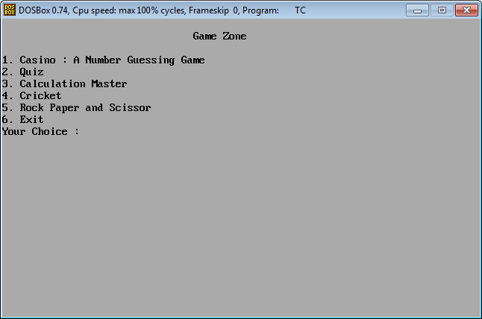

By Pressing 1

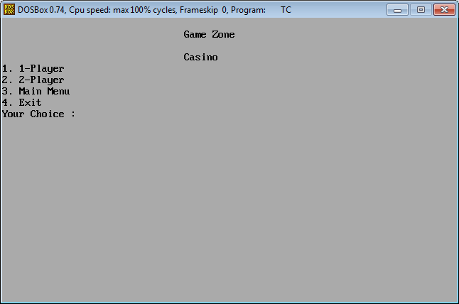

By Pressing 1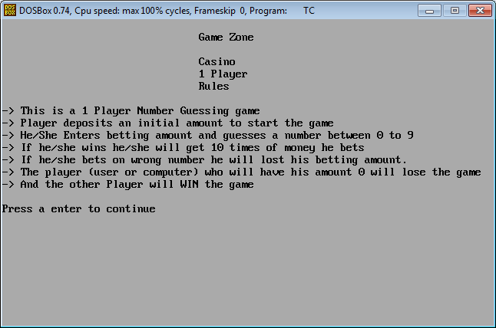 By Pressing enter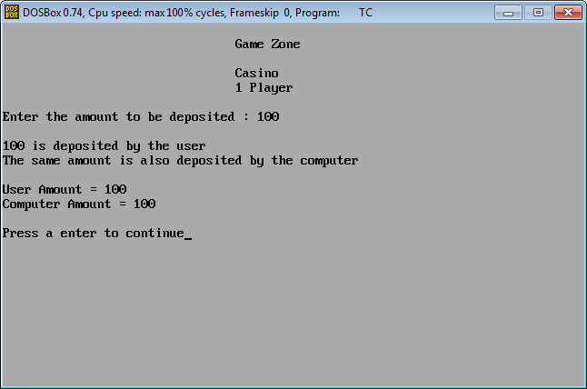

By Pressing enter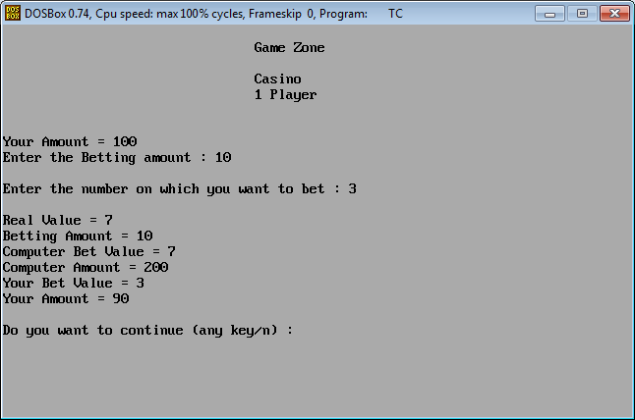 By Pressing n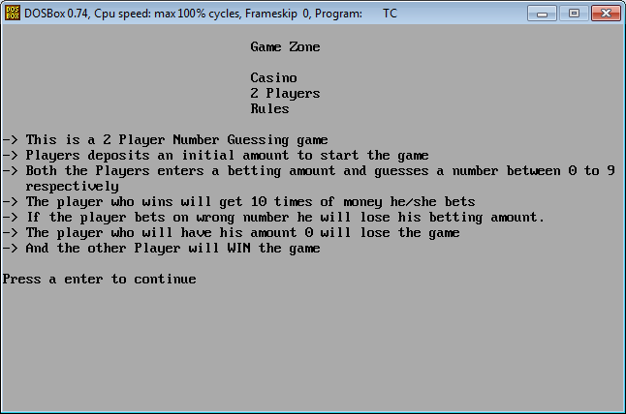 By Pressing enter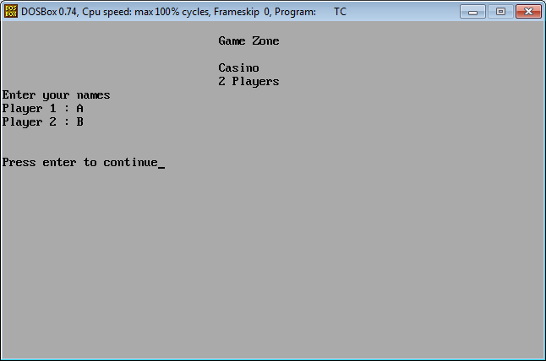

By Pressing enter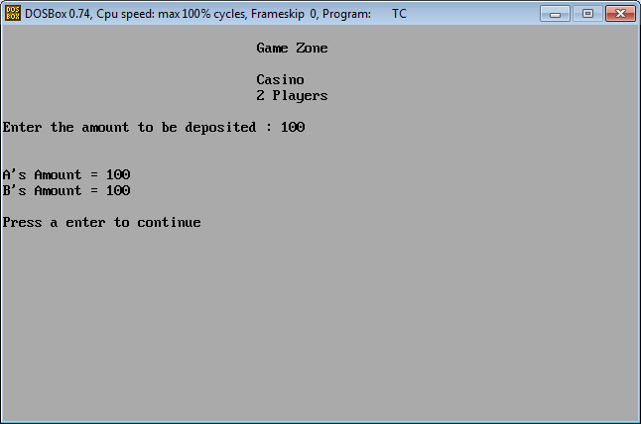 By Pressing any key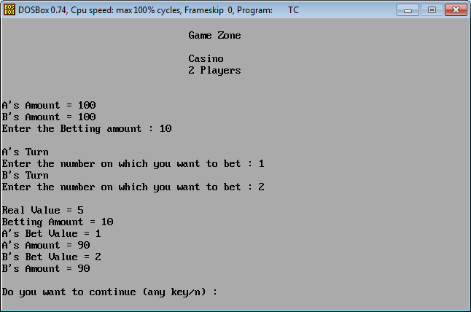

By Pressing any key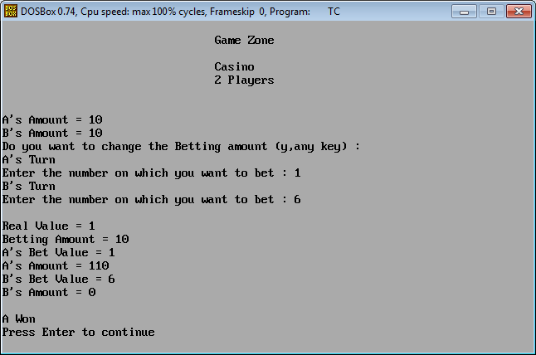 By Pressing enter and going to quiz via main menu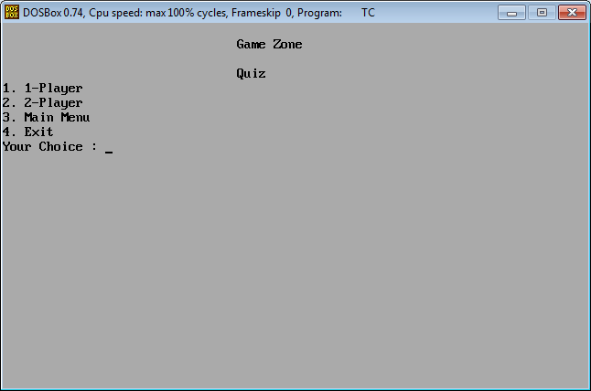

By Pressing 1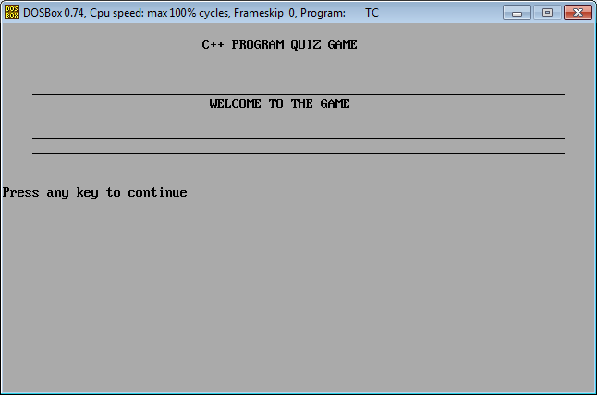 By Pressing 1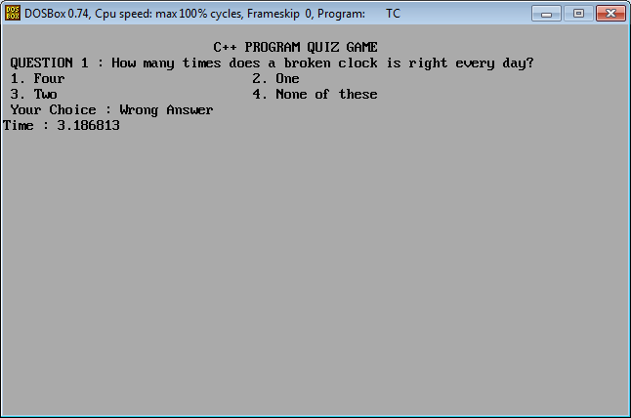

By Pressing 4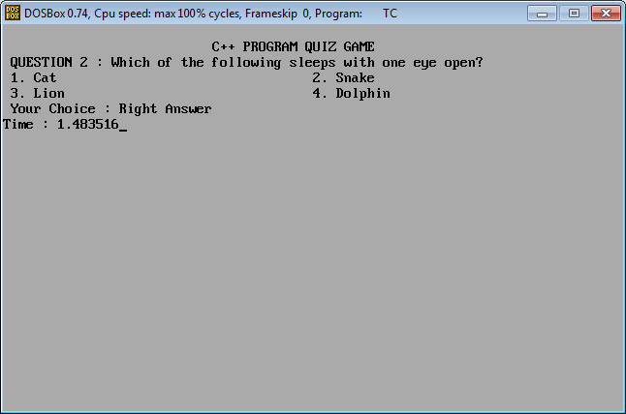 By Pressing enter and going to quiz two player via main menu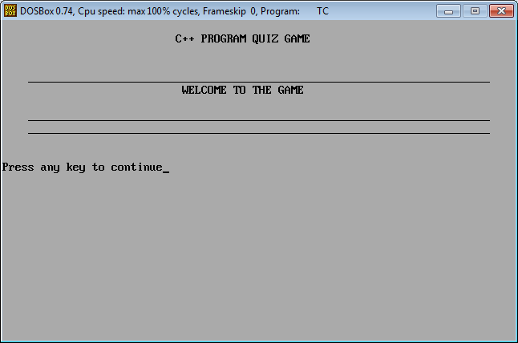

By Pressing Respective answers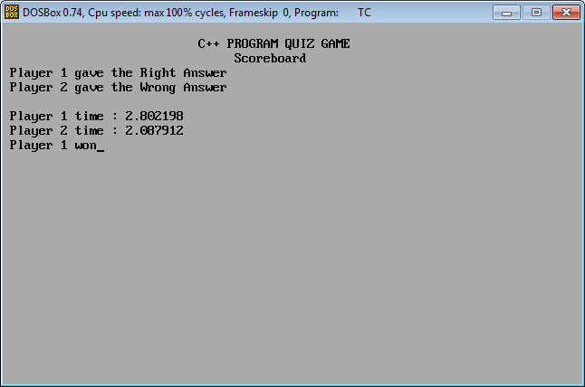 By Pressing enter and going to Calculation Master via main menu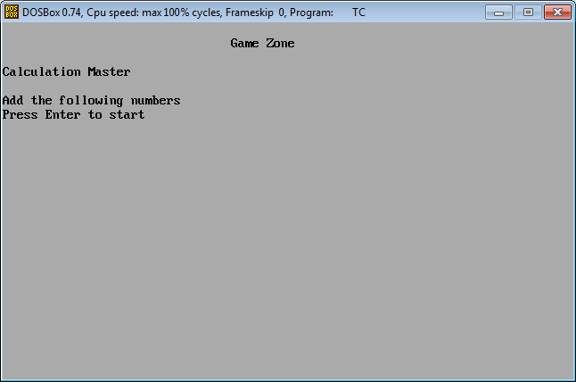

By Pressing enter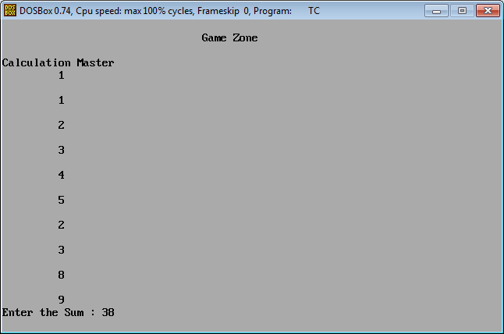 By Pressing enter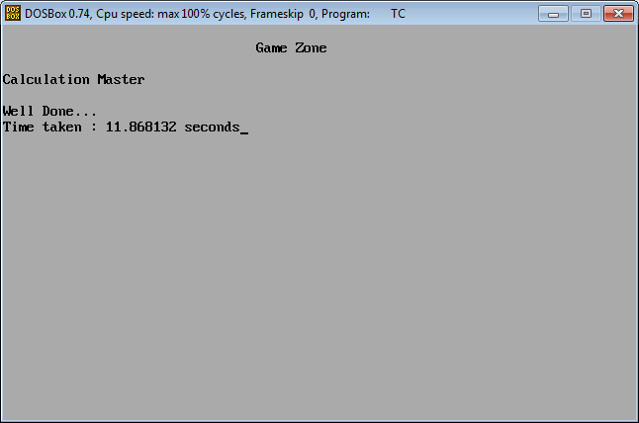

By Pressing enter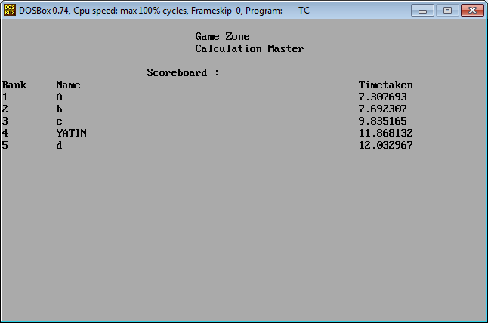 By Pressing enter and going to cricket via main menu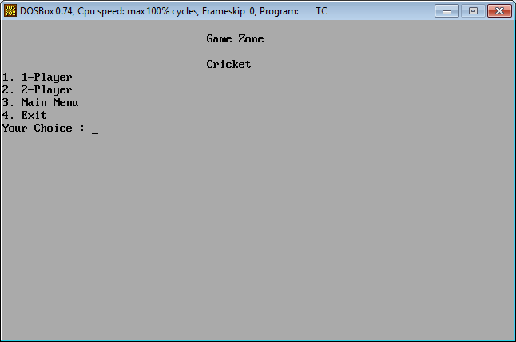

By Pressing 1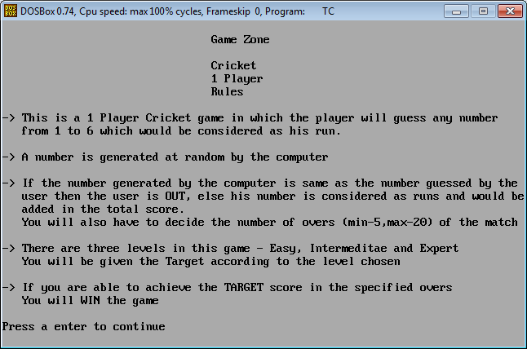 By Pressing 1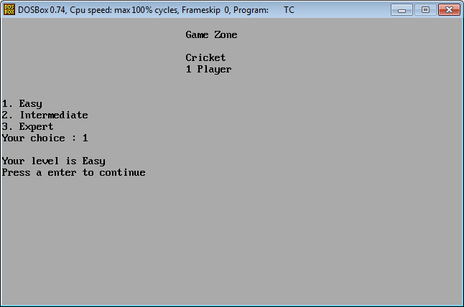

By Pressing enter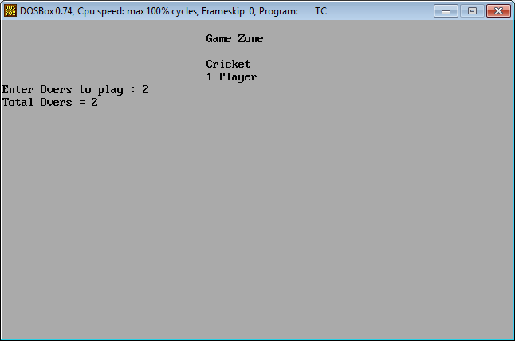 By Pressing enter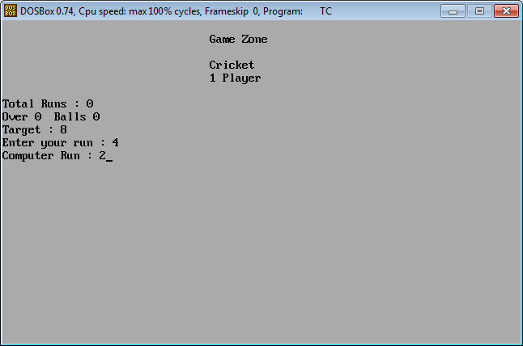

By Pressing enter

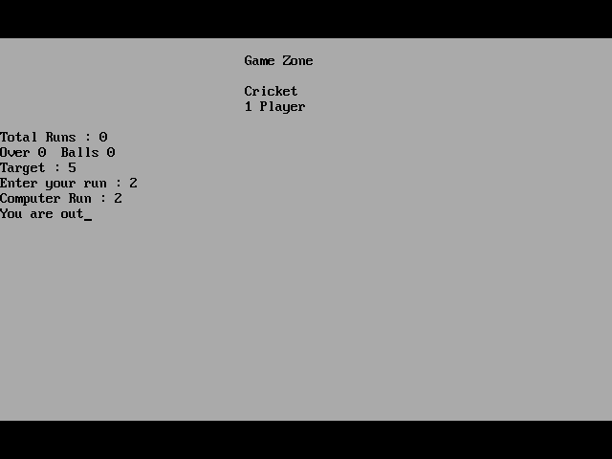

By Pressing enter and going to two players via main menu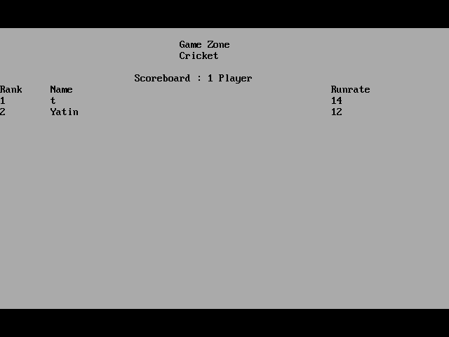

By Pressing enter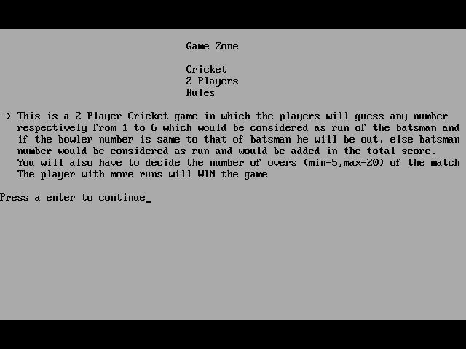

By Pressing enter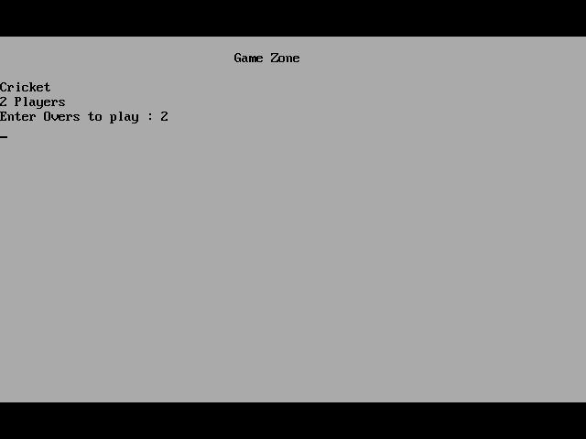

By Pressing enter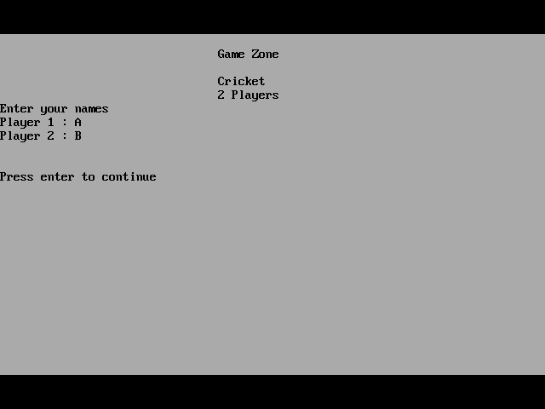

By Pressing enter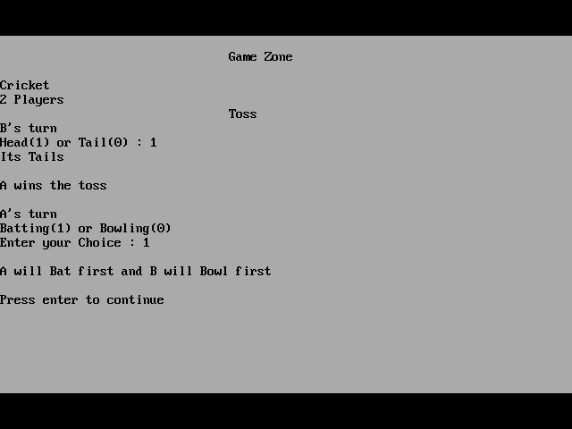

By Pressing enter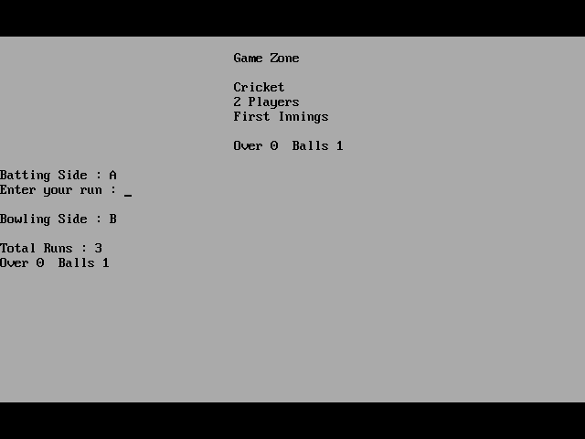

By Pressing enter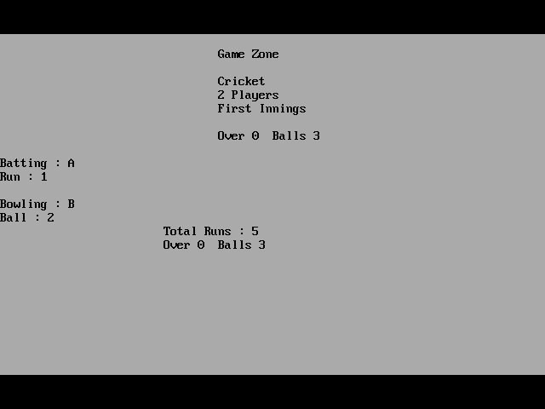

By Pressing enter

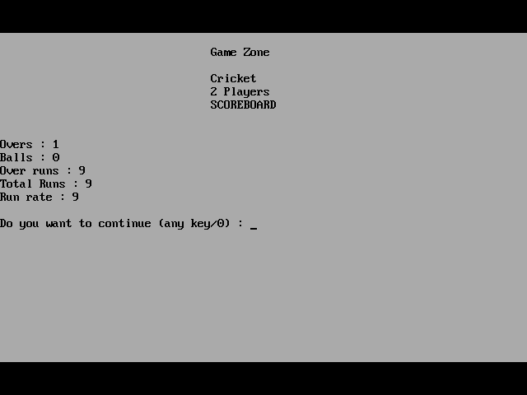

By Pressing any key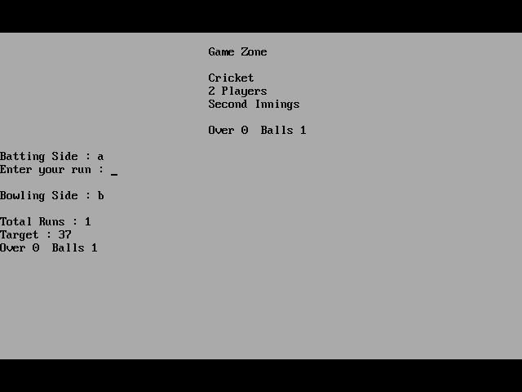

By Pressing enter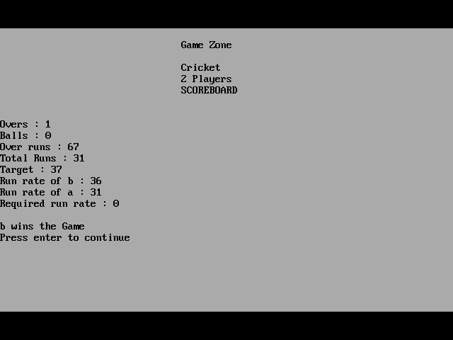

By Pressing enter and going to Rock Paper Scissor via main menu

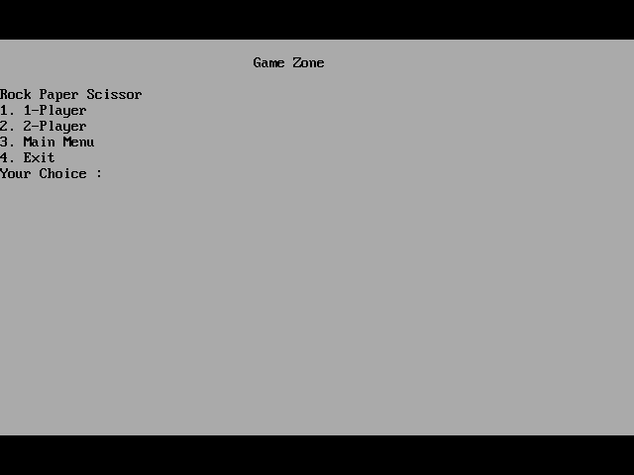

By Pressing 1

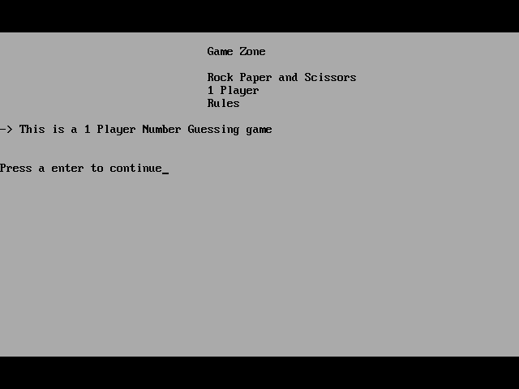

By Pressing enter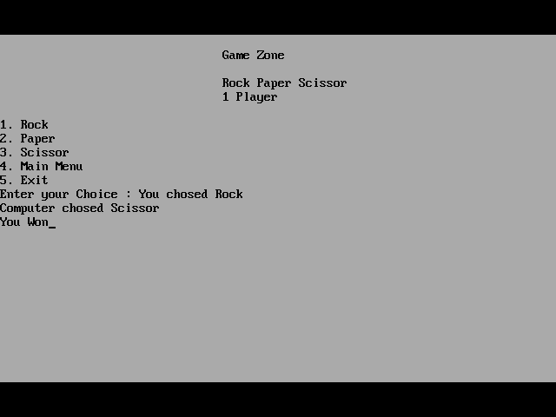

By Pressing enter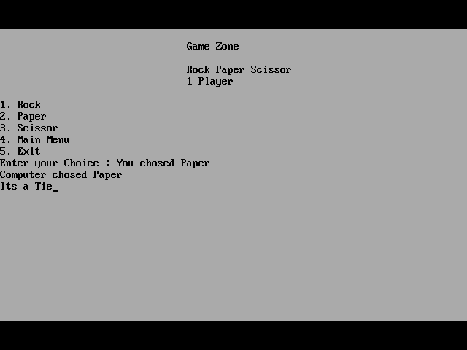

By Pressing enter